

[**Project and Professionalism**](https://classroom.google.com/u/0/c/NTQ0MDE5NDQ5ODcx)

**(6CS007)**

# Artifact Design and Test Plan

University ID : 2059742

## Student Name : Parbat Lama

Group : L6CG8

Submitted on : 21st January 2023

**Table of content**

1. DFD.................................................................................3
2. SRS List + Activity Diagram.............................................4-10
3. User registration & verification subsystem.......4-5
4. Ballot Creation & Distribution Sub System.......6
5. Vote Casting Sub System................................7
6. Result Tabulation Sub System........................8
7. User Interface Sub System.............................9-10
8. Use case diagram........................................................11-13
9. Wireframe ....................................................................14-23
10. Class diagram...............................................................24
11. ERD ..............................................................................25
12. Data Dictionary..............................................................26-27
13. Sequence Diagram........................................................28

# DFD

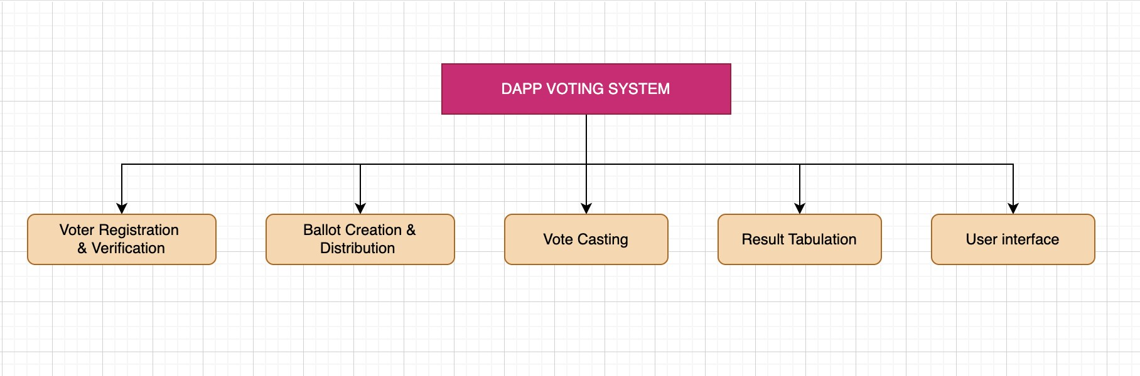

# SRS List

## 1. User Registration & Verification Sub System

1. Ability to securely capture and store voter information, including name, address, and identification documents.
2. Ability to verify the identity of voters using government-issued ID or other forms of identification.
3. Ability to verify the eligibility of voters based on citizenship, age, and residence requirements.
4. Ability to prevent duplicate registrations and ensure that each voter is only able to register once.
5. Ability to maintain the privacy and security of voter information, including protection against unauthorized access or tampering.
6. Ability to handle a high volume of registrations and potential demand spikes during peak periods. vii. Ability to integrate with other subsystems, such as the ballot design and votecasting subsystems.
7. Ability to handle any additional requirements or constraints specific to the voting process, such as accessibility requirements for individuals with disabilities.
8. Ability to handle any additional requirements or constraints specific to the jurisdiction where the voting takes place.
9. Ability to provide a user-friendly interface for voters to register and verify their identity.

## Activity Diagram

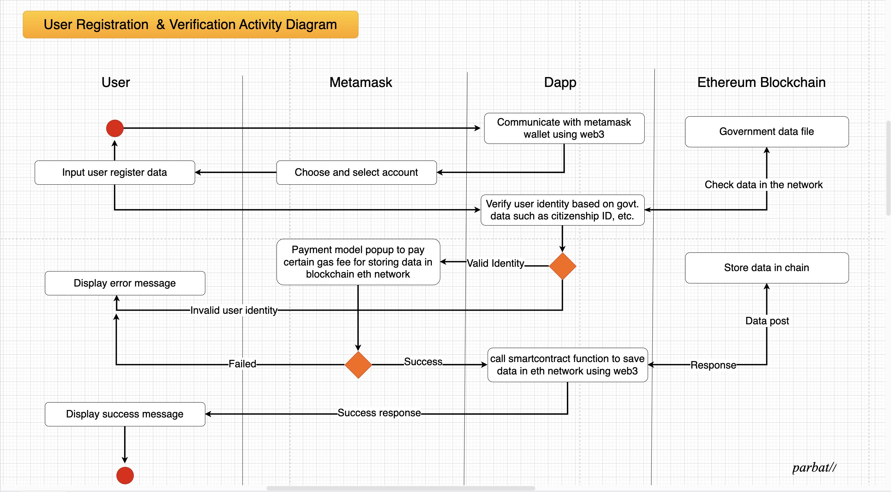

## 2. Ballot Creation & Distribution Sub System

1. Ability to design and format the ballot in a clear and intuitive manner, including presenting the choices and instructions to voters in a clear and concise way.
2. Ability to handle multiple languages and handle any additional requirements or constraints specific to the voting process, such as accessibility requirements for individuals with disabilities.
3. Ability to create digital or physical ballots, depending on the requirements of the voting process.
4. Ability to distribute ballots to voters in a secure and reliable manner, whether digitally or physically.
5. Ability to track the distribution of ballots and ensure that each voter receives only one ballot.
6. Ability to handle a high volume of ballots and handle potential spikes in demand during peak periods. vii. Ability to integrate with other subsystems, such as the voter registration and vote casting subsystems.
7. Ability to handle any additional requirements or constraints specific to the jurisdiction where the voting takes place.
8. Ability to provide a user-friendly interface for voters to access and use the ballot.

Activity Diagram

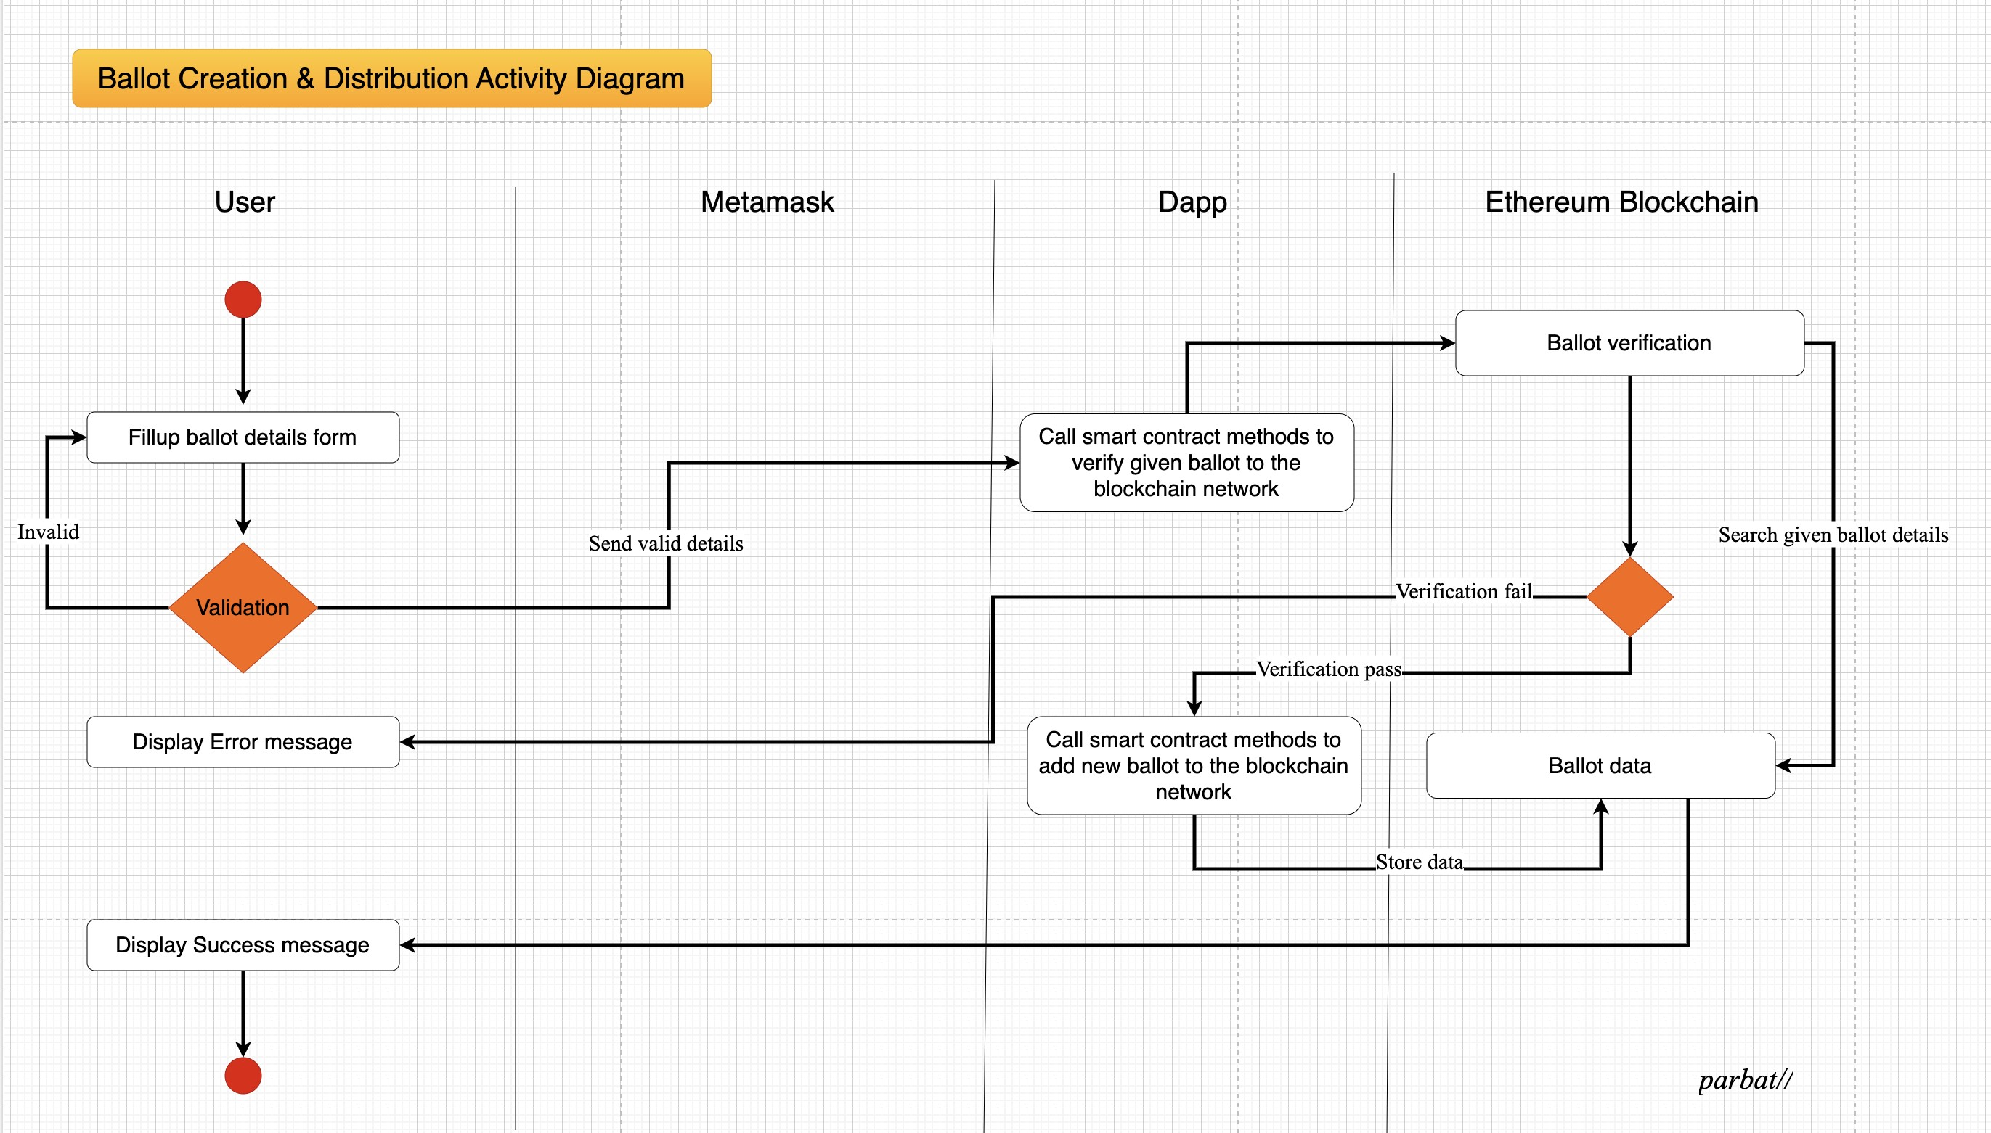

## 3. Vote Casting Sub System

1. Ability to securely authenticate voters and verify their eligibility to cast a vote.
2. Ability to handle multiple methods of voting, such as online, by phone, or in person.
3. Ability to handle a high volume of votes and potential demand spikes during peak periods.
4. Ability to ensure the privacy and security of the voting process, including protecting against unauthorized access or tampering.
5. Ability to integrate with other subsystems, such as the voter registration and ballot creation subsystems.
6. Ability to handle any additional requirements or constraints specific to the voting process, such as accessibility requirements for individuals with disabilities.
7. Ability to handle any additional requirements or constraints specific to the jurisdiction where the voting takes place.
8. Ability to provide a user-friendly interface for voters to cast their votes.

Activity Diagram

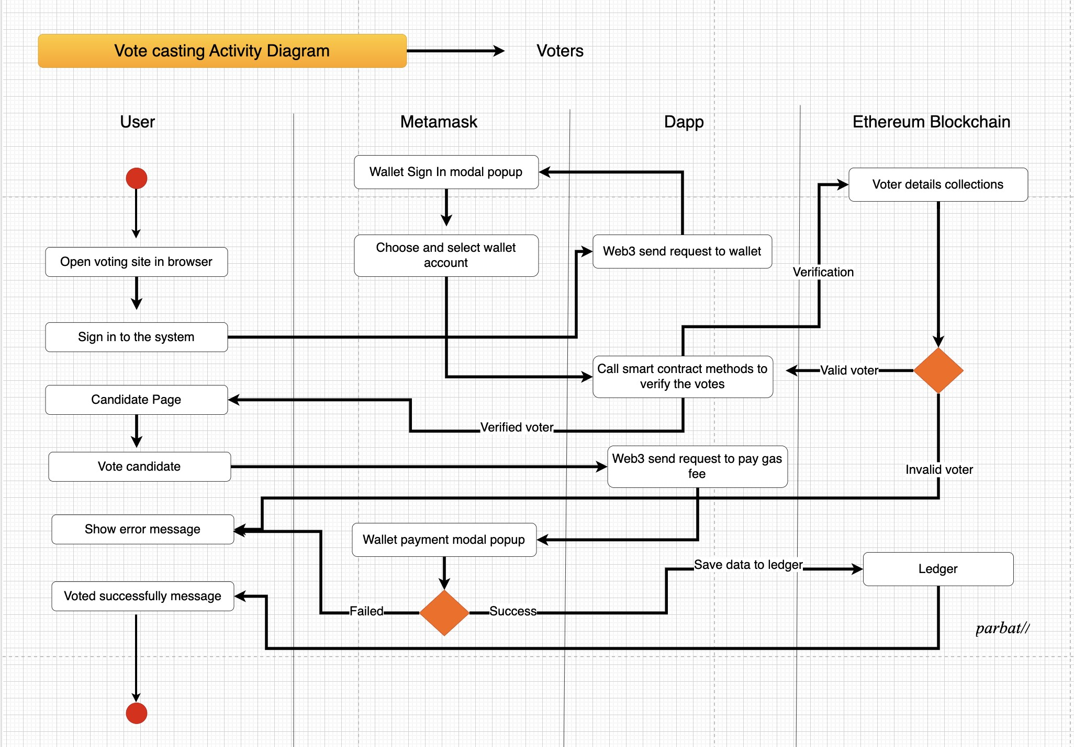

## 4. Result Tabulation Sub System

1. Ability to accurately tally the votes and determine the results of the election.
2. Ability to use cryptographic techniques or smart contracts to ensure the integrity and transparency of the vote count.
3. Ability to handle a high volume of votes and potential demand spikes during peak periods.
4. Ability to ensure the privacy and security of the voting process, including protecting against unauthorized access or tampering.
5. Ability to integrate with other subsystems, such as the vote casting and results reporting subsystems.
6. Ability to handle any additional requirements or constraints specific to the voting process, such as rules for handling tie votes or contested elections.
7. Ability to handle any additional requirements or constraints specific to the jurisdiction where the voting takes place.
8. Ability to provide a user-friendly interface for voters to view the results of the election.

Activity Diagram

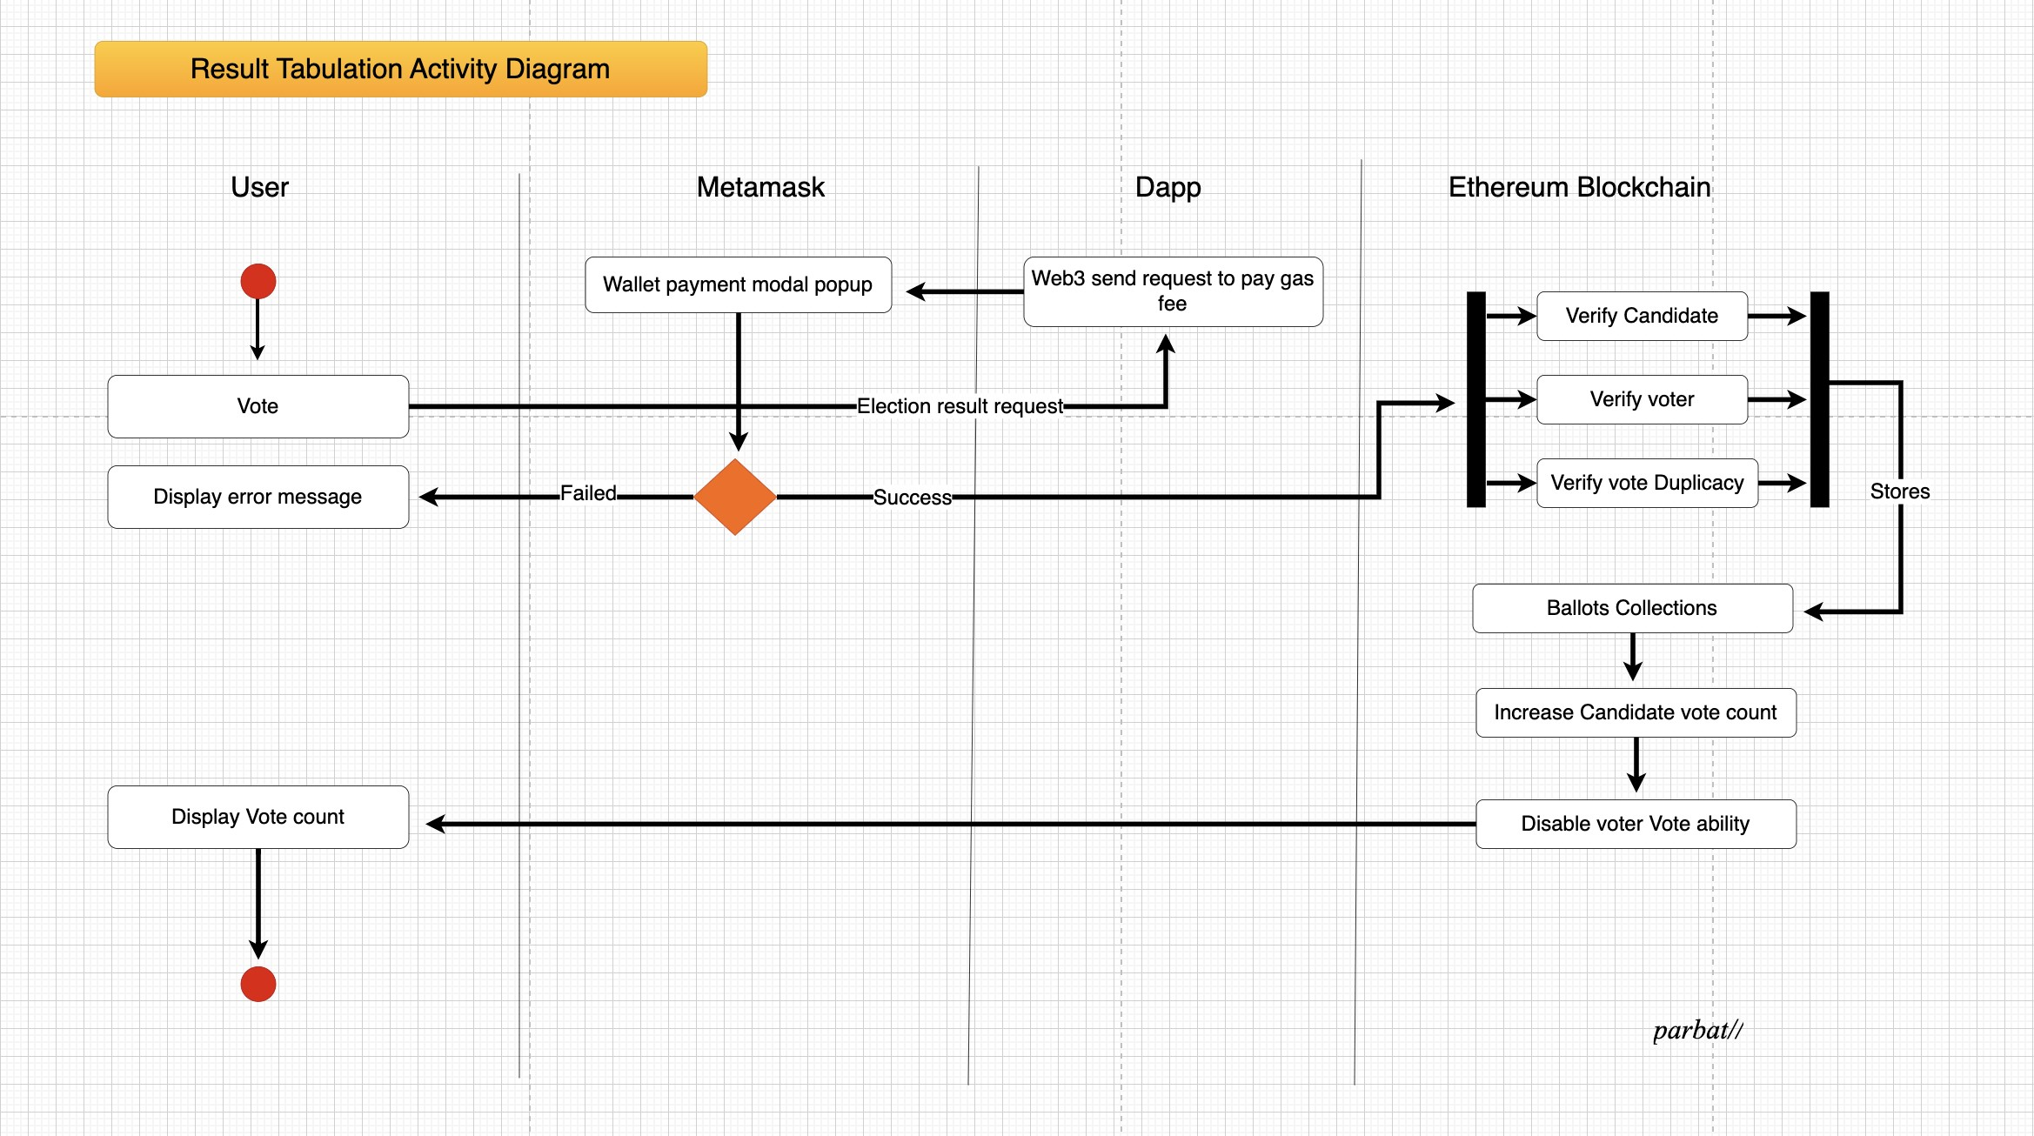

## 5. User Interface Sub System

1. Ability to provide a clear and intuitive interface for users to interact with the

system.

1. Ability to handle multiple languages and handle any additional requirements or constraints specific to the voting process, such as accessibility requirements for individuals with disabilities.
2. Ability to handle a high volume of requests and potential demand spikes during peak periods.
3. Ability to integrate with other subsystems, such as voter registration, ballot creation, vote casting, and result tabulation subsystems.
4. Ability to handle any additional requirements or constraints specific to the jurisdiction where the voting takes place.
5. Ability to provide a responsive design that is compatible with different devices and browsers. vii. Ability to provide a secure login system for users to access their accounts and cast their votes.
6. Ability to provide clear and concise instructions and guidance to users throughout the voting process.
7. Ability to provide a user-friendly interface for voters to view the results of the election.

Activity Diagram

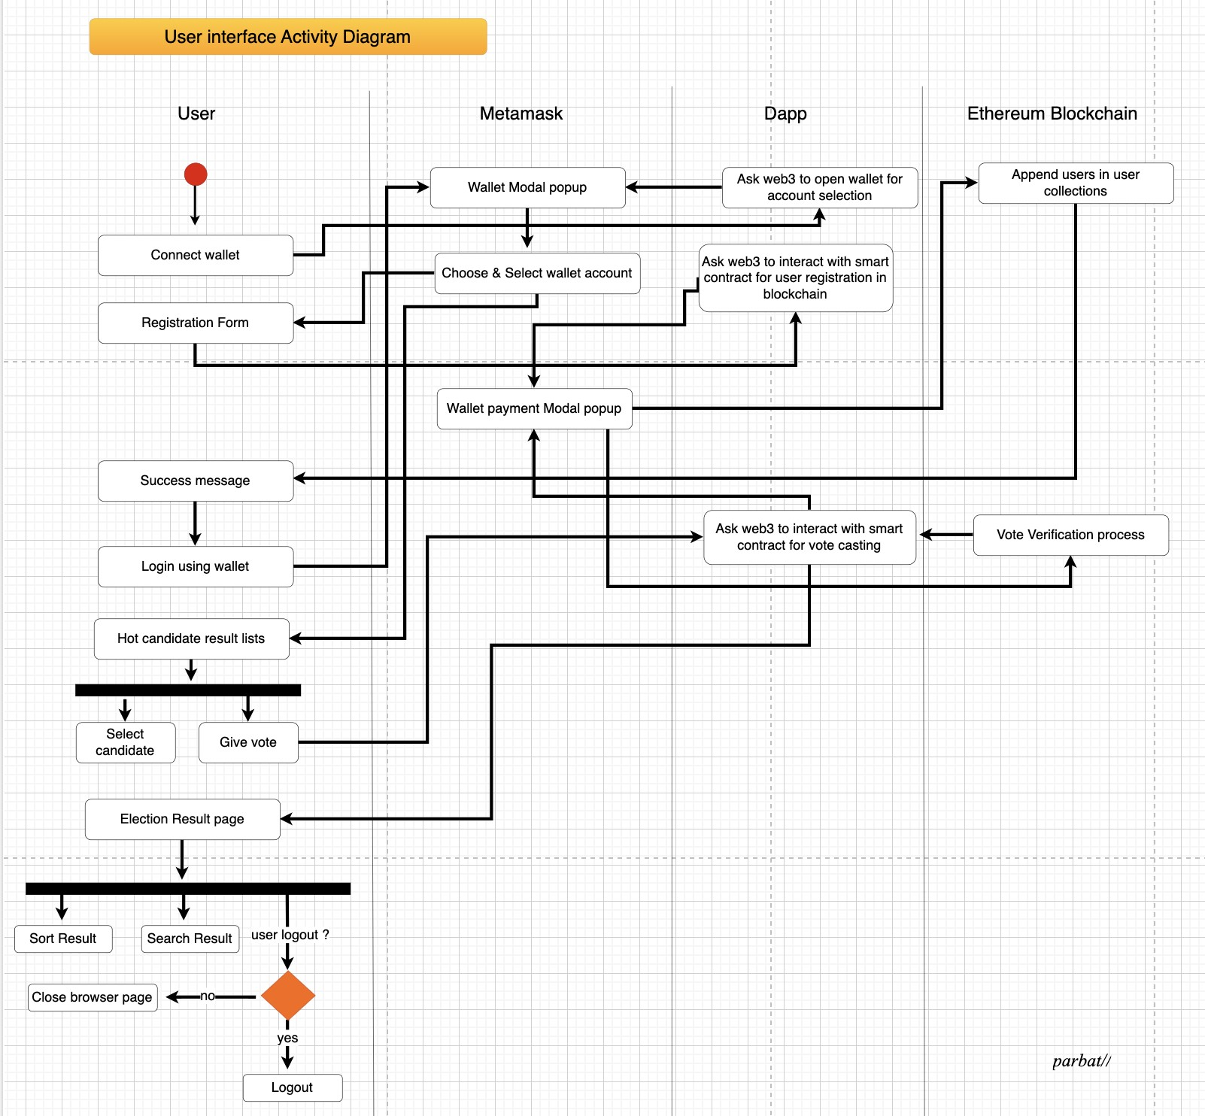

# USE CASE DIAGRAM

1. User registration

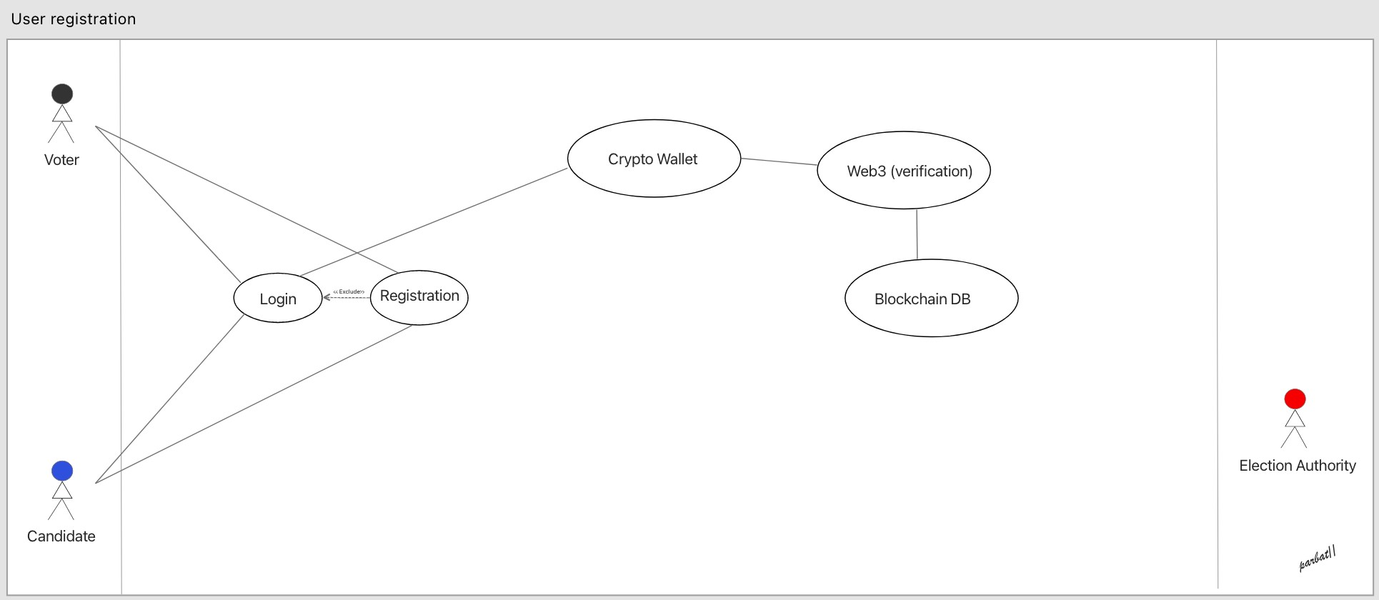

1. Ballot Creation

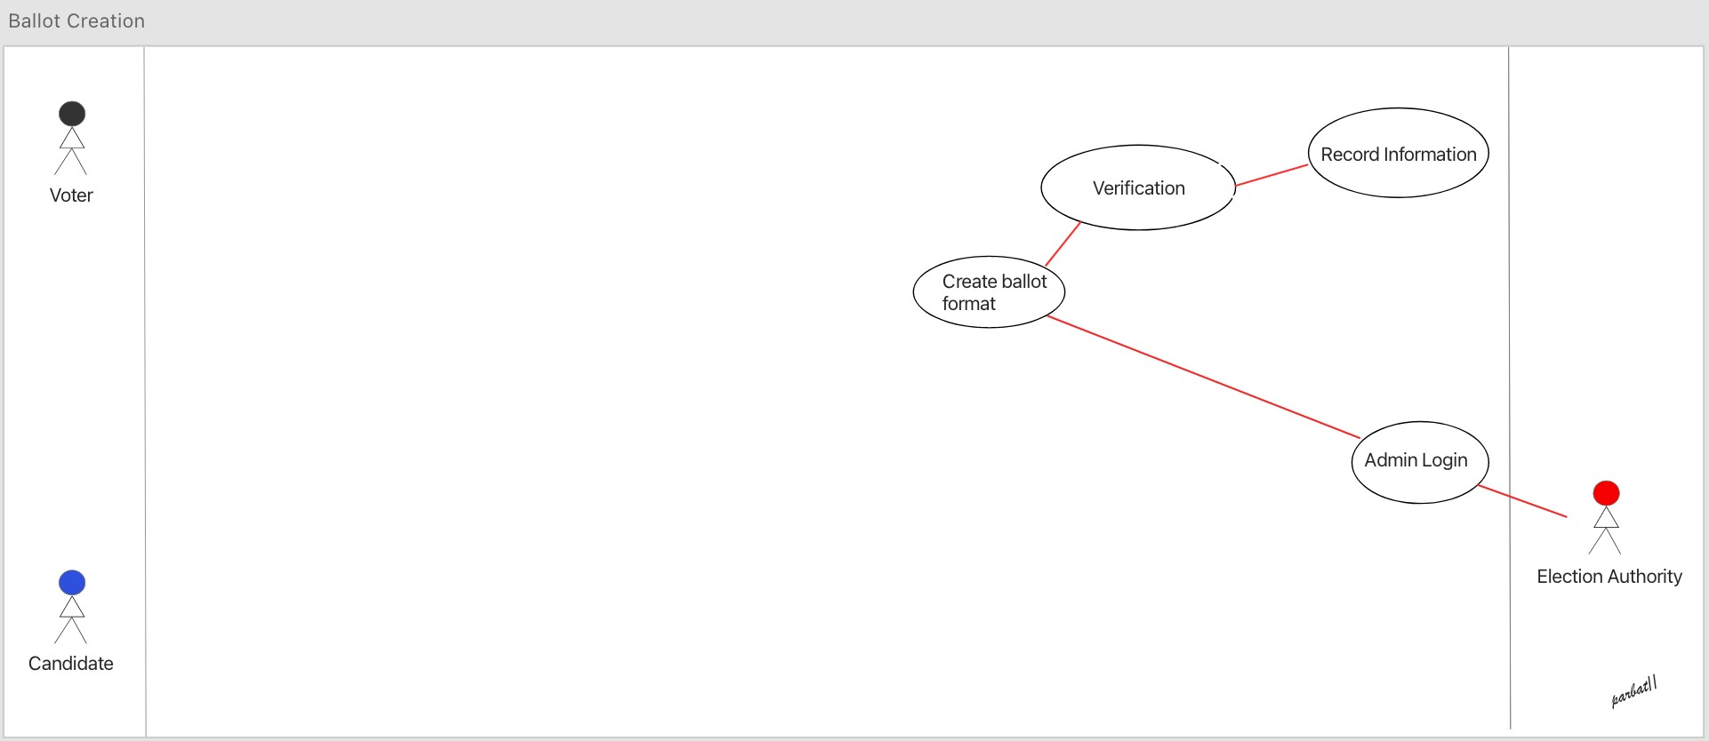

1. Vote casting

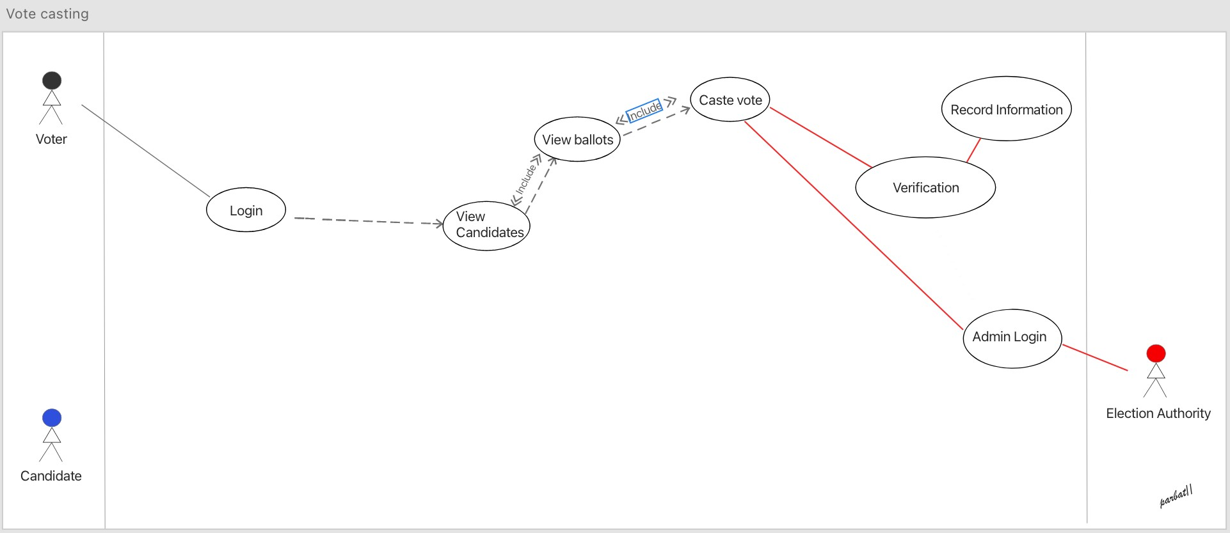

1. Result tabulation

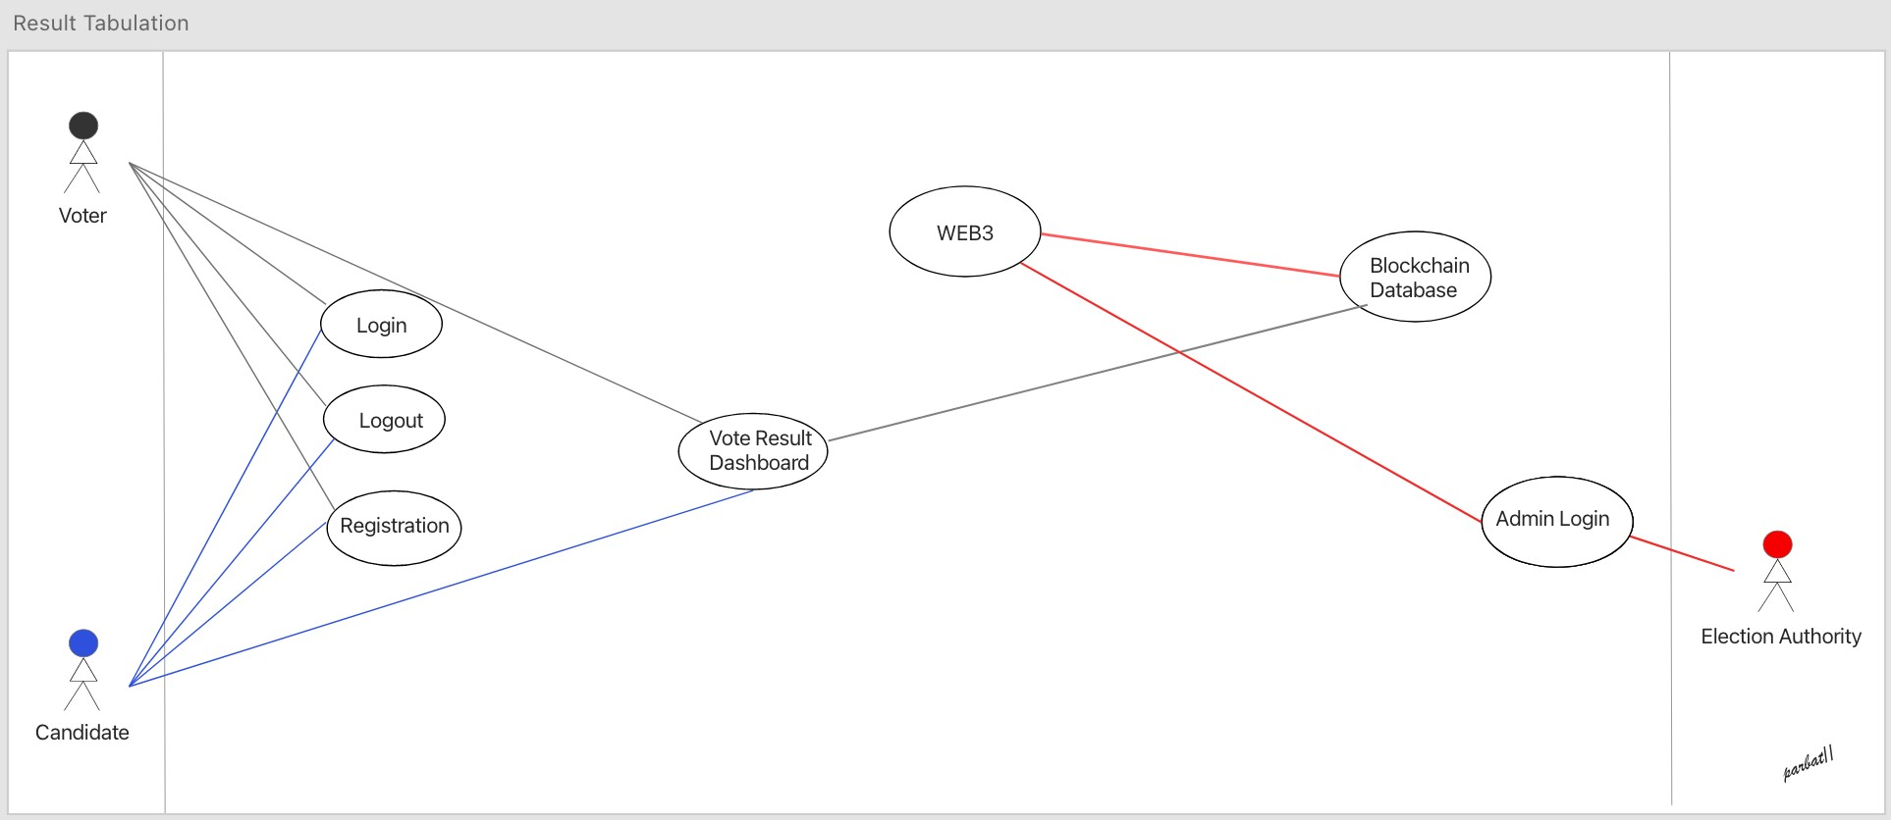

1. Create election

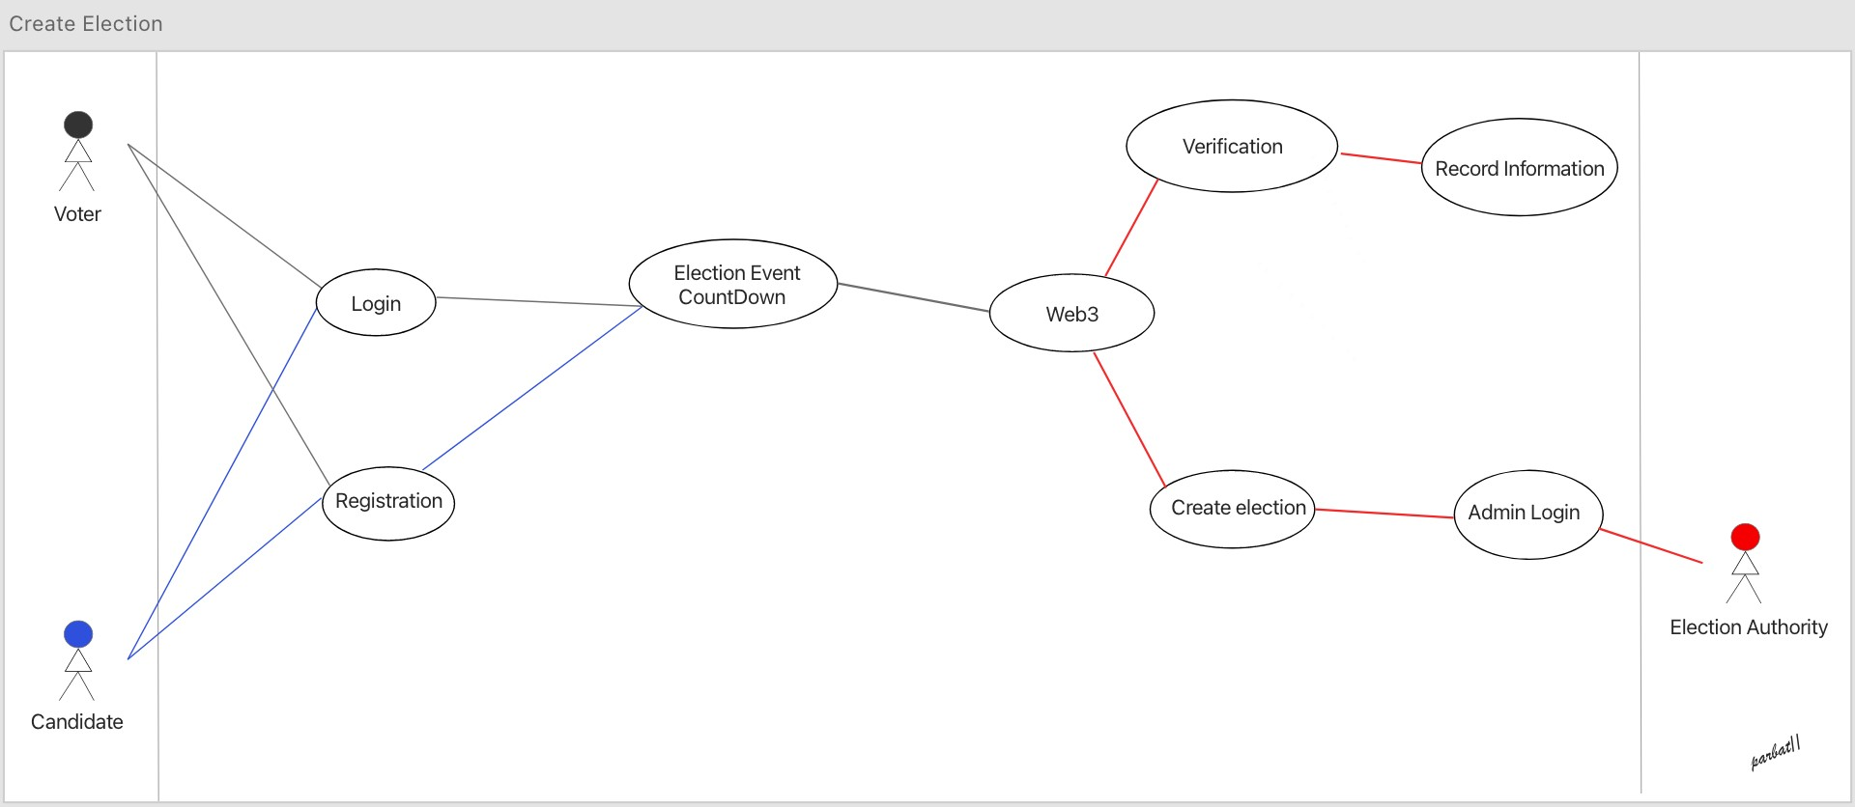

1. Candidate selection

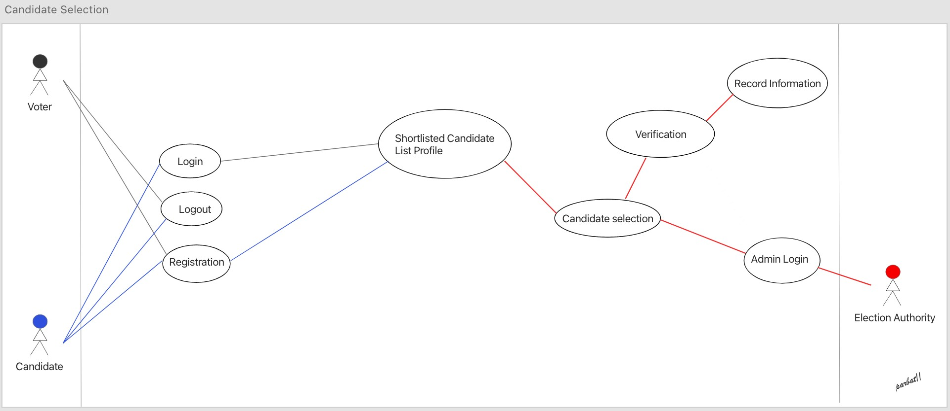

1. Create election policies

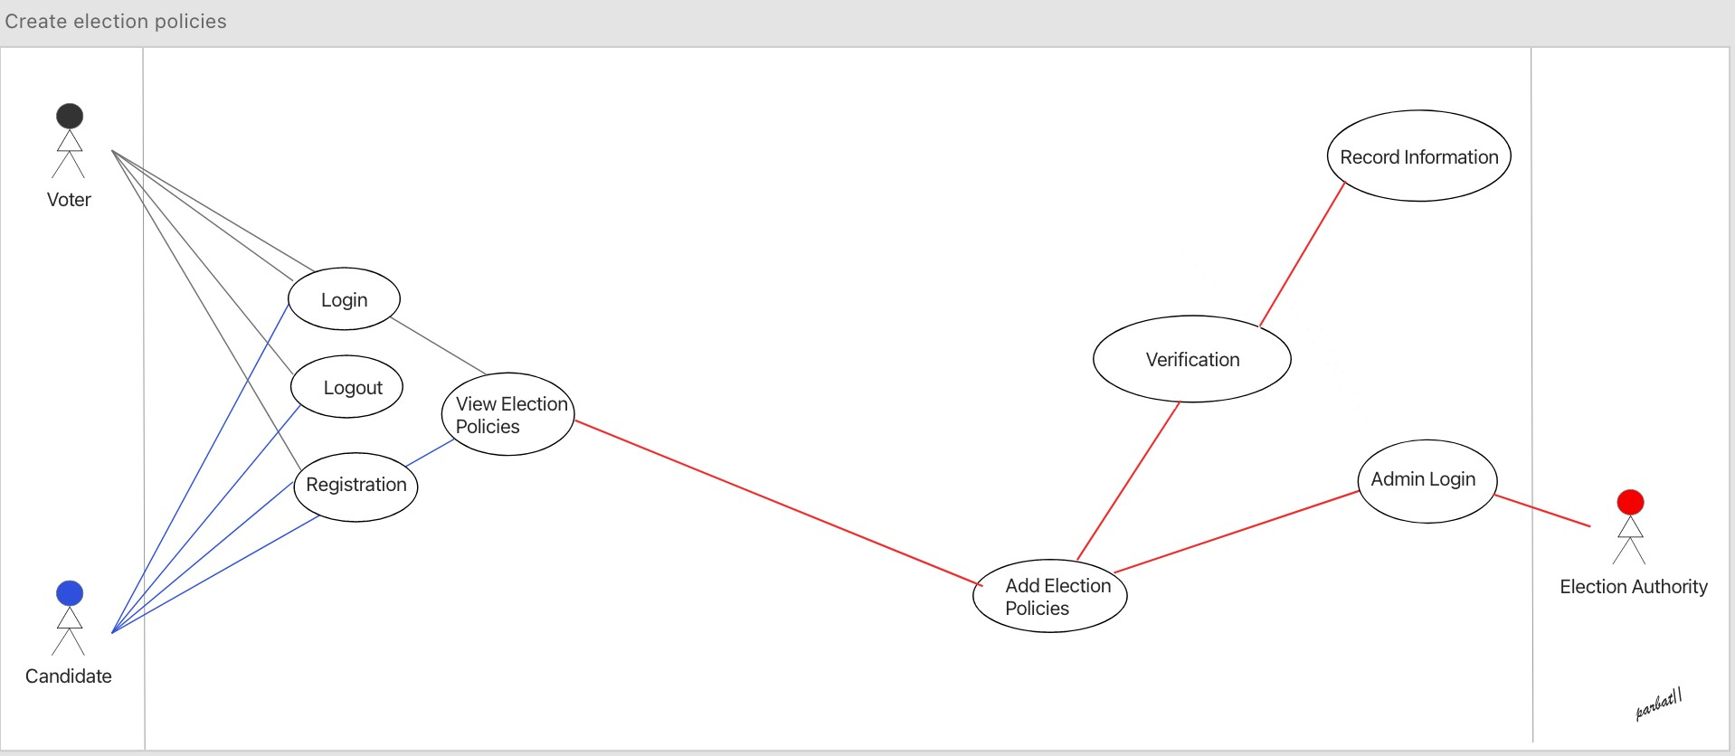

# Wireframe

1. About page

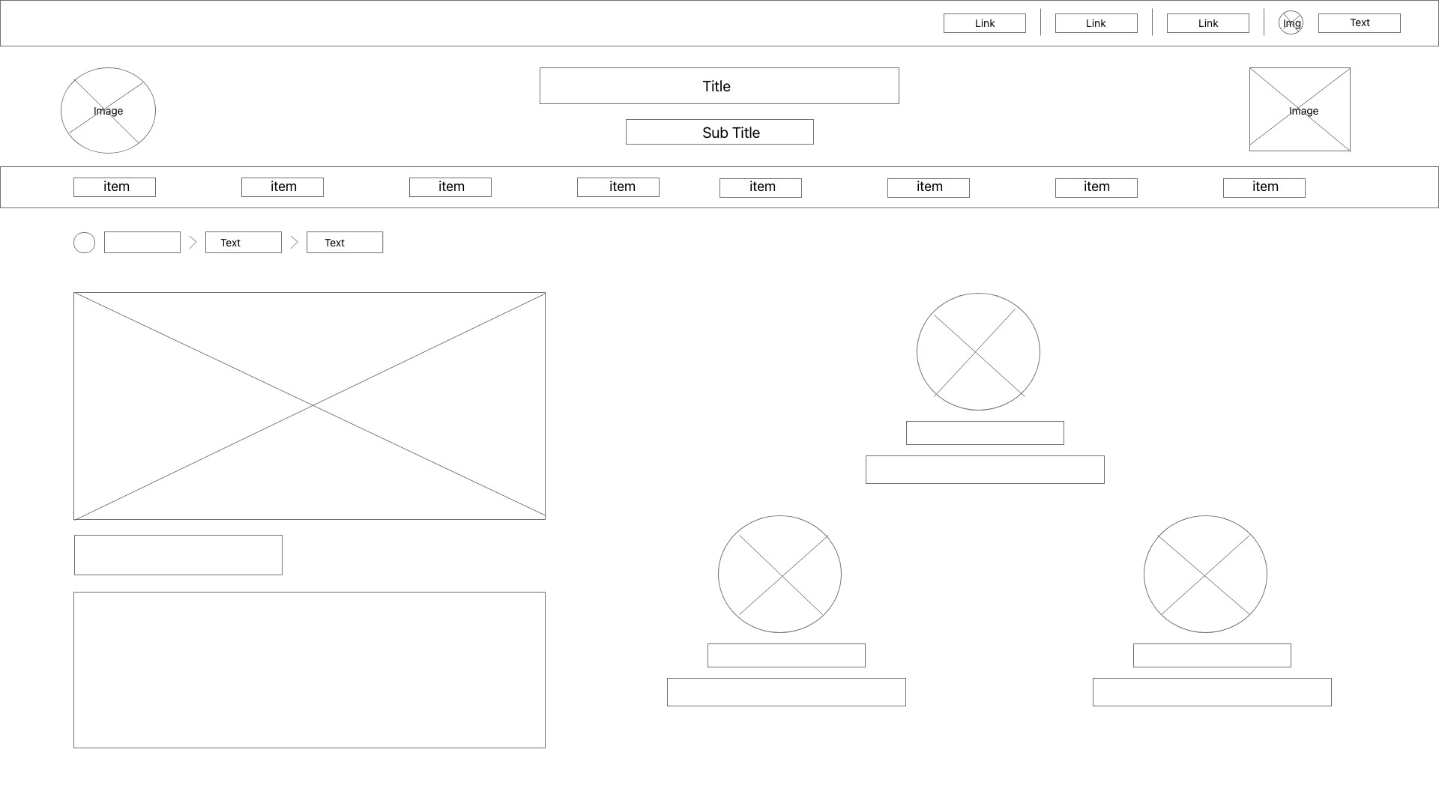

1. Candidate details page

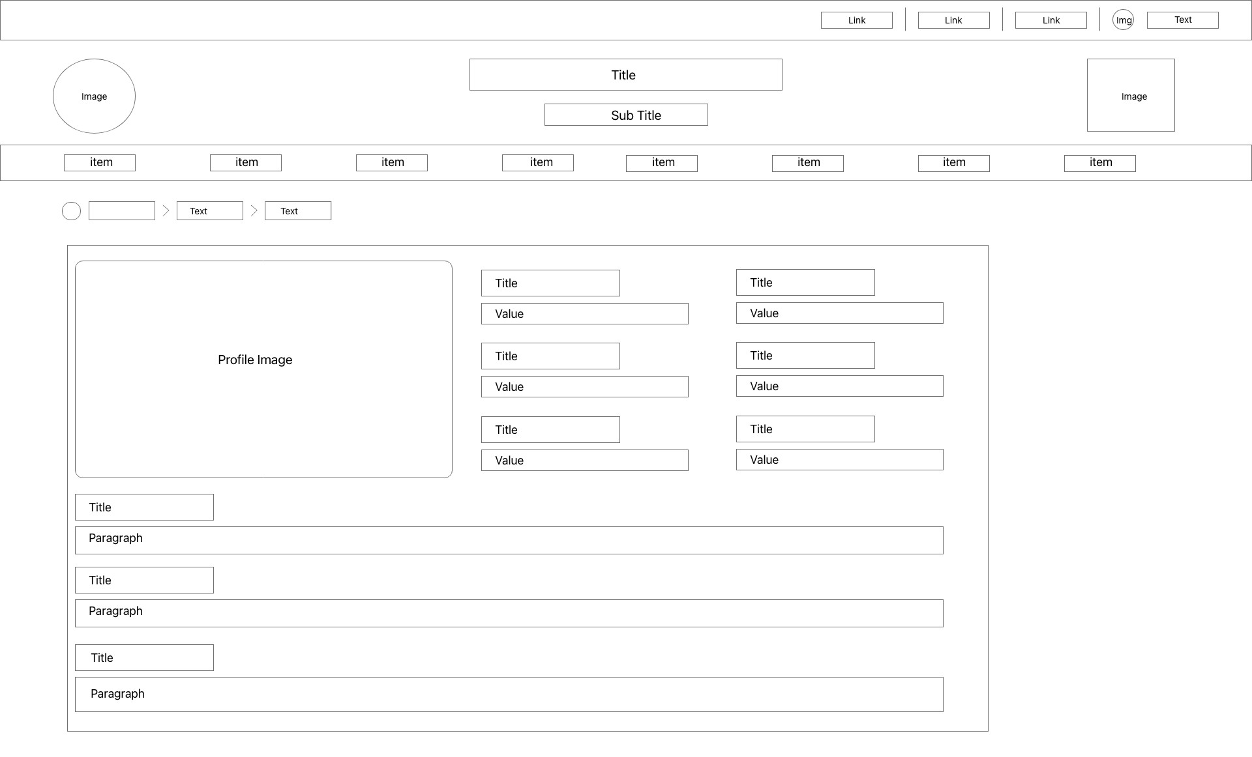

1. Candidate Lists page

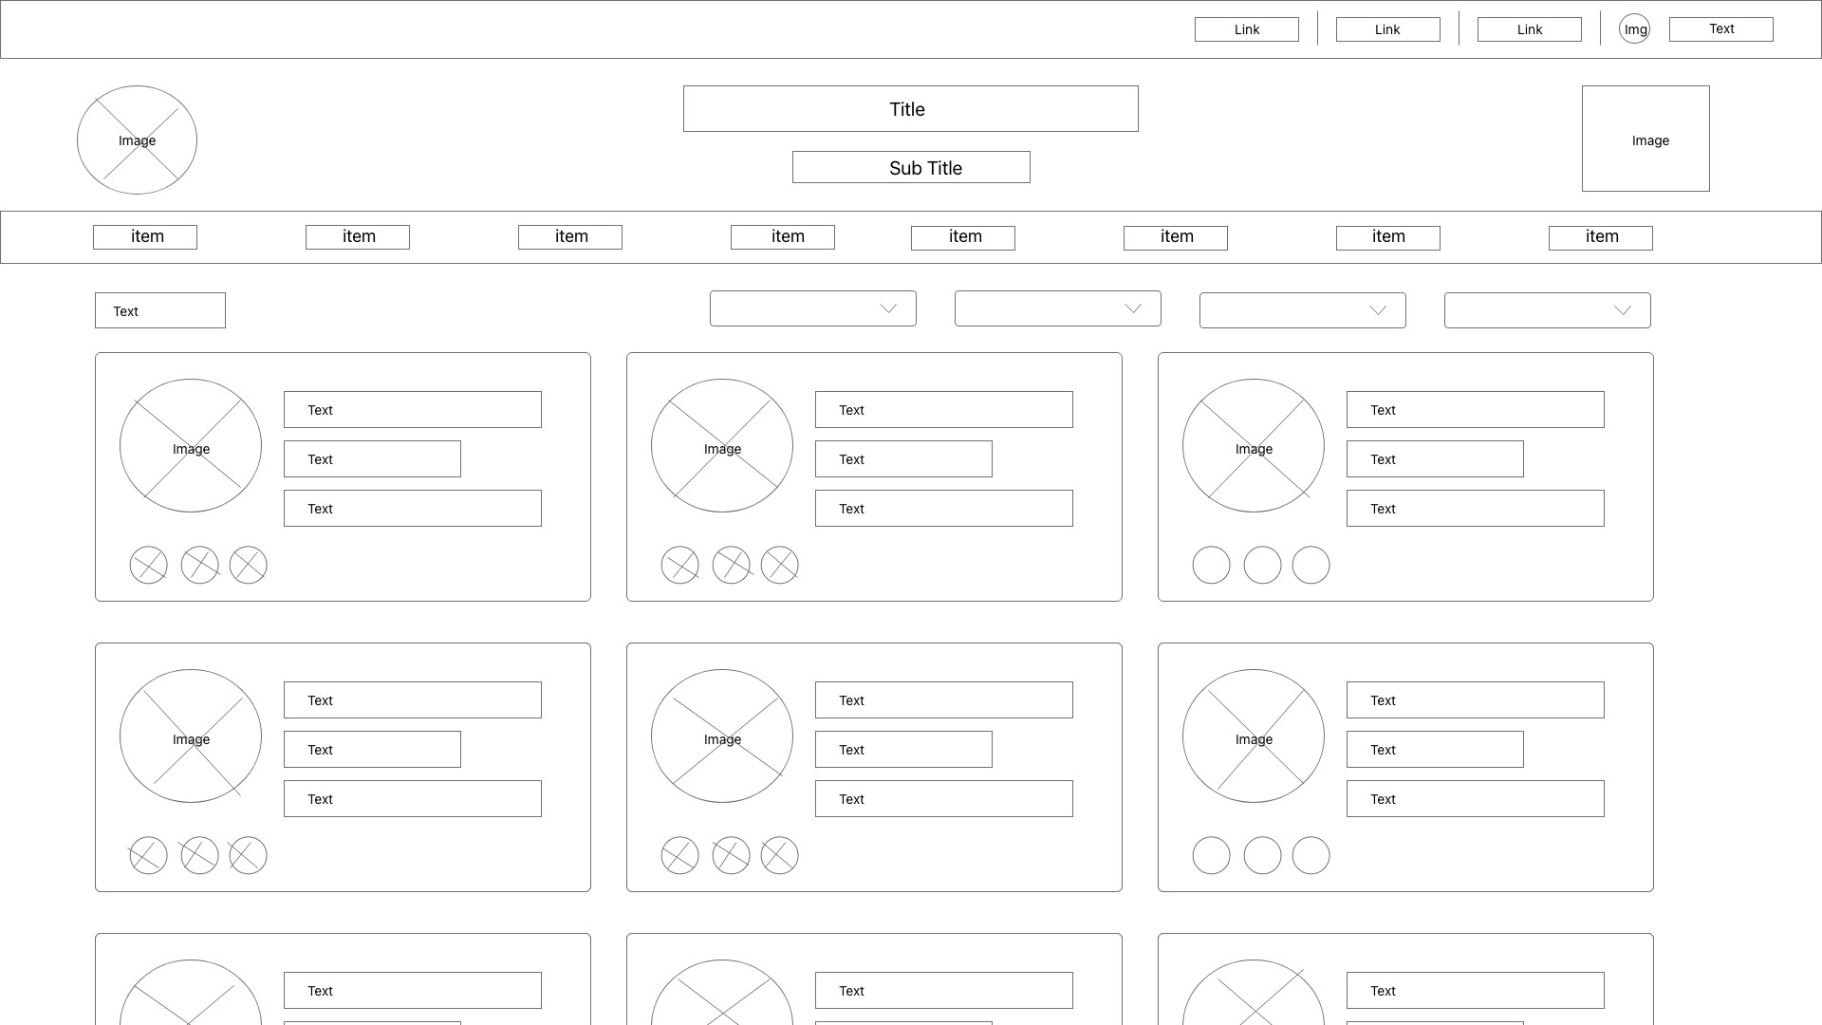

1. Candidate registration page

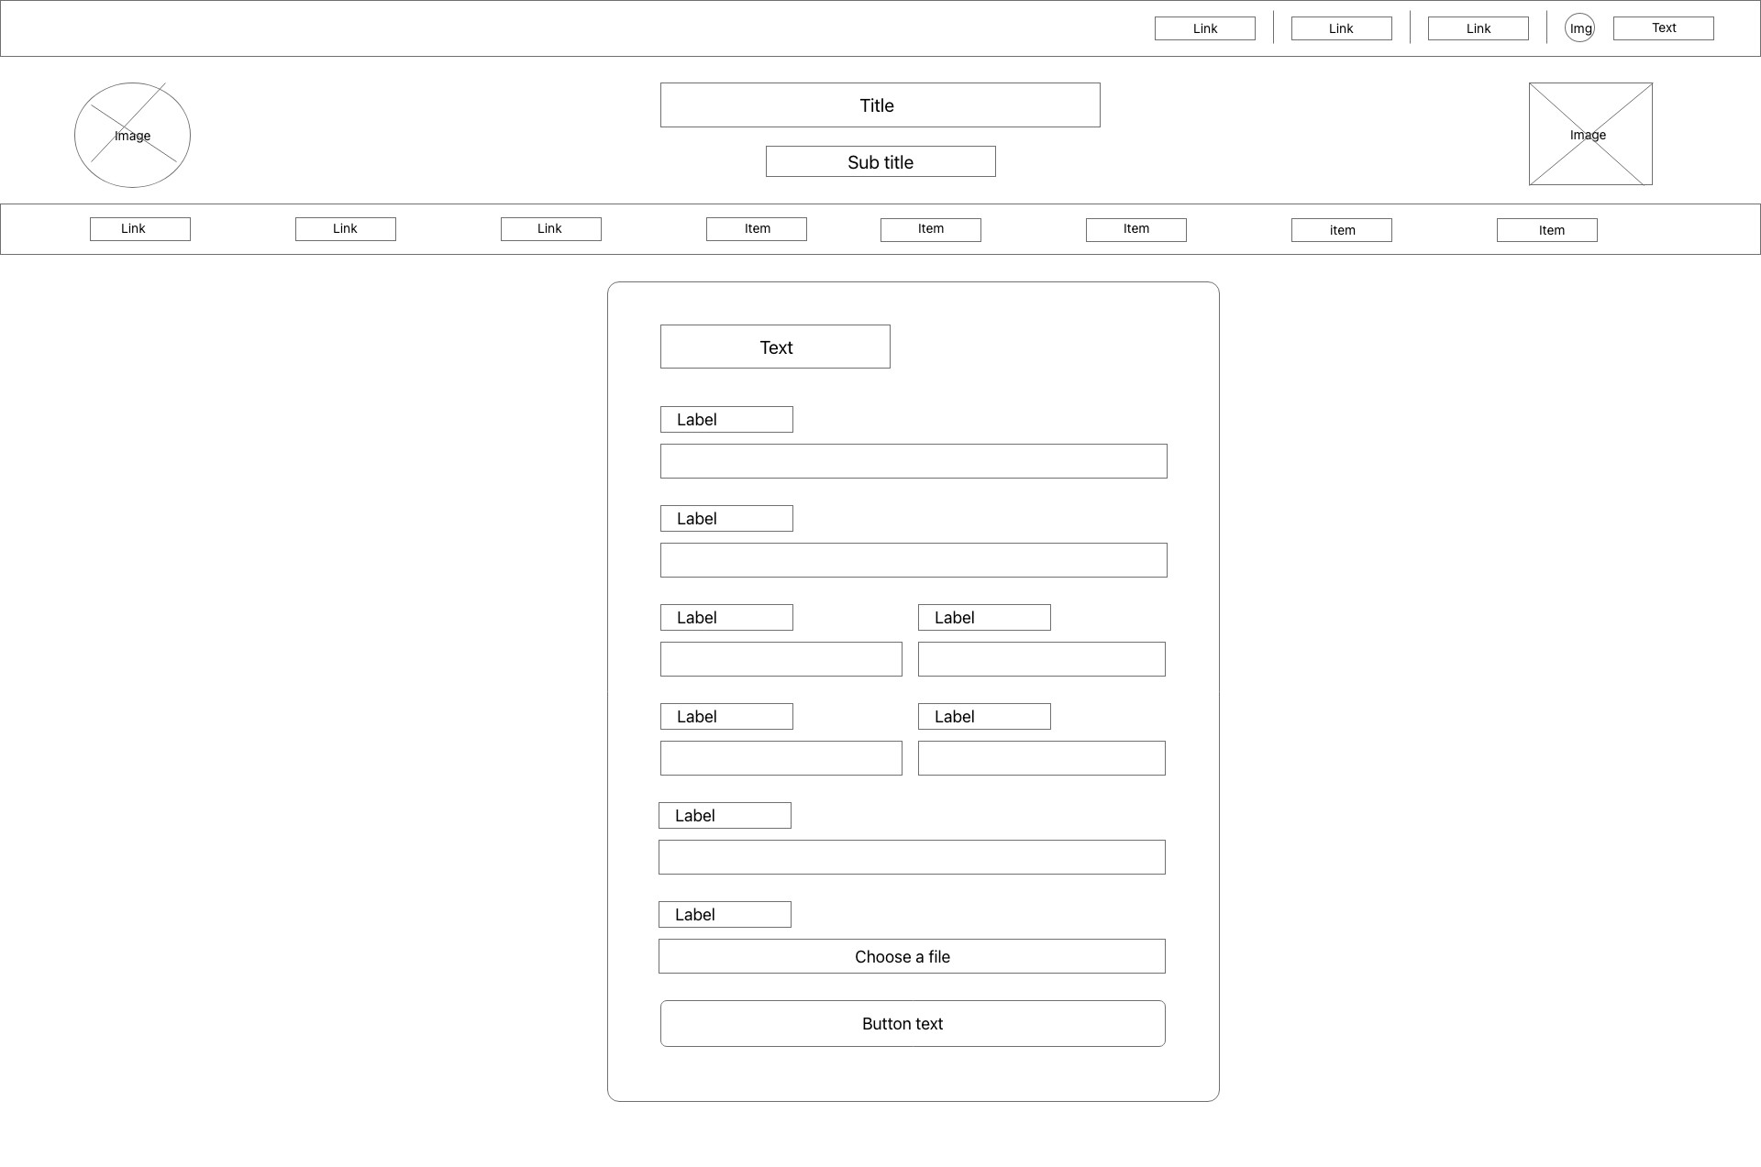

5 Constitutional provision page

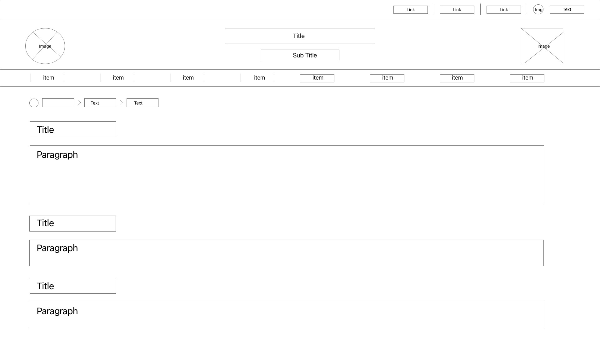

6. Create new election page

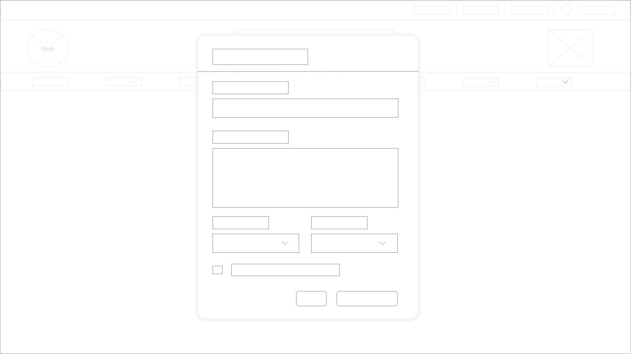

7 Navigation bar dropdown

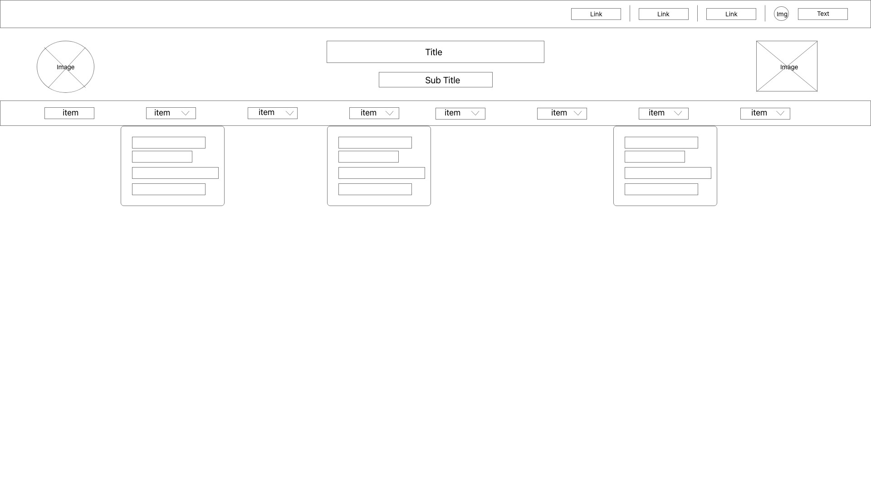

8. Hot seats page

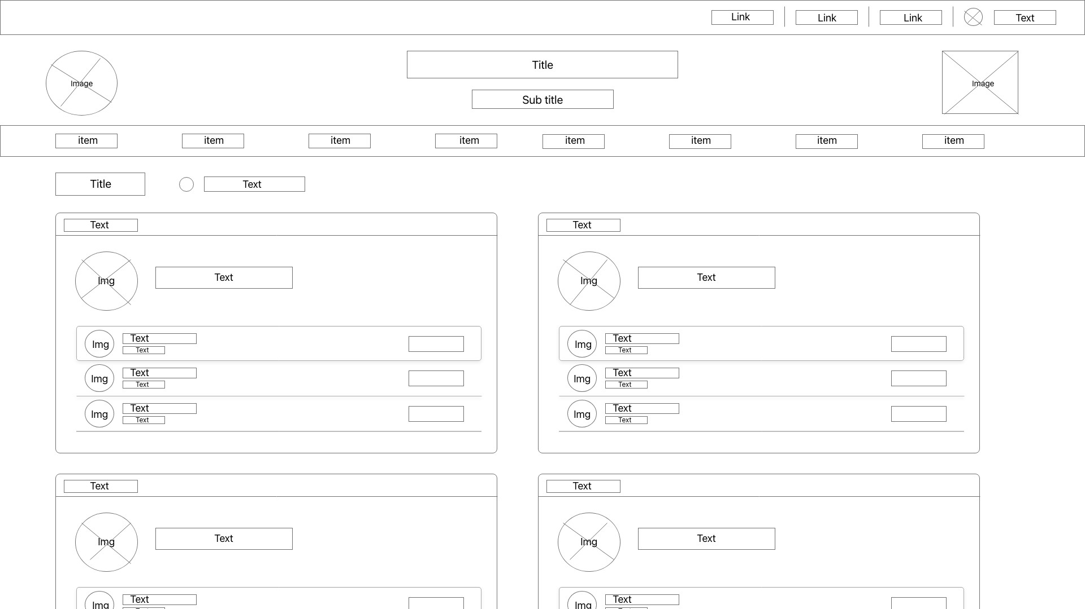

9 Political party details page

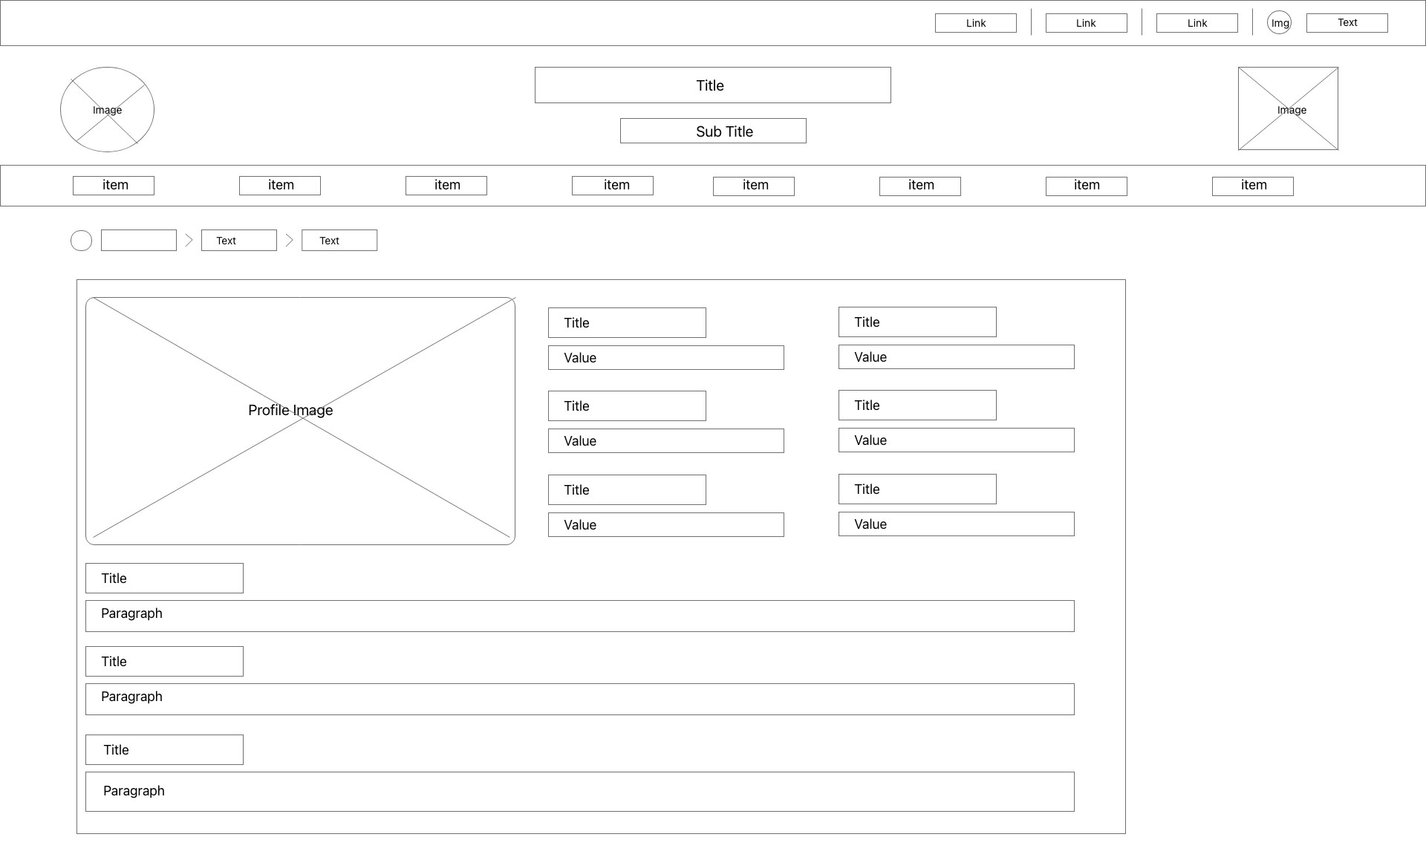

10. Party List page

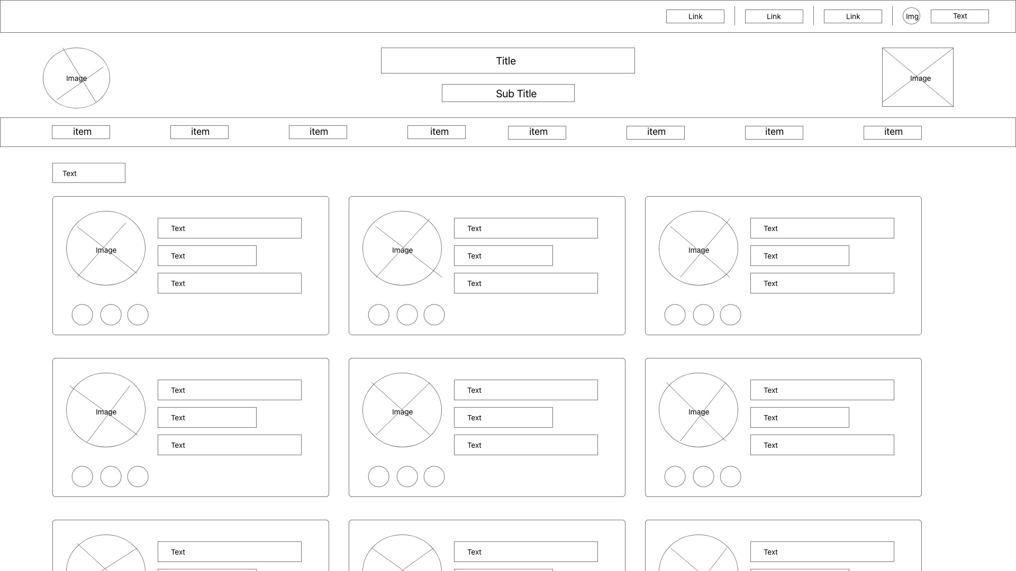

11 Party Registration page

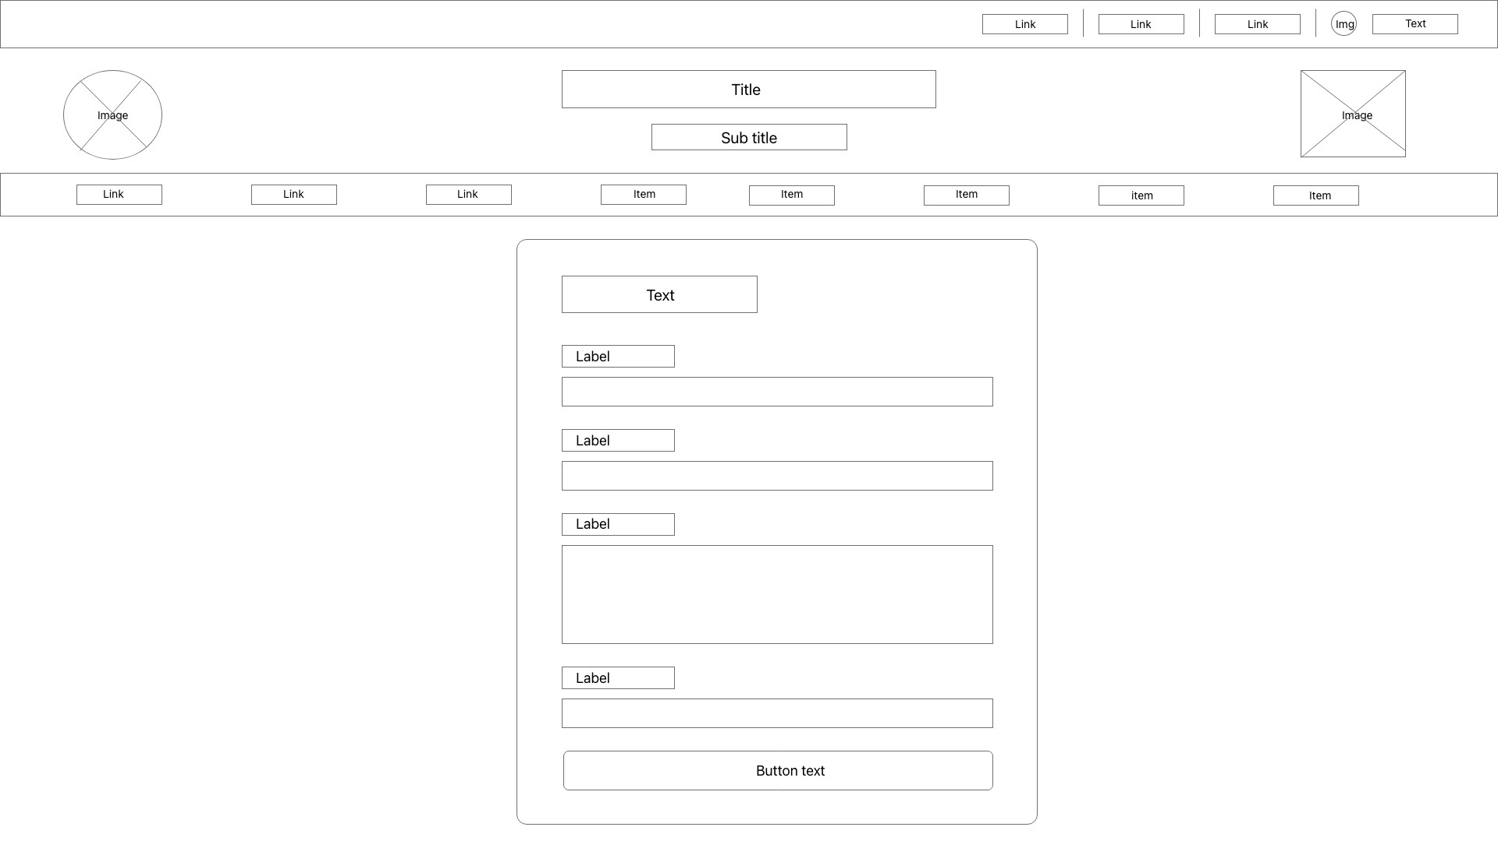

1. Privacy Policy page



1. Search modal

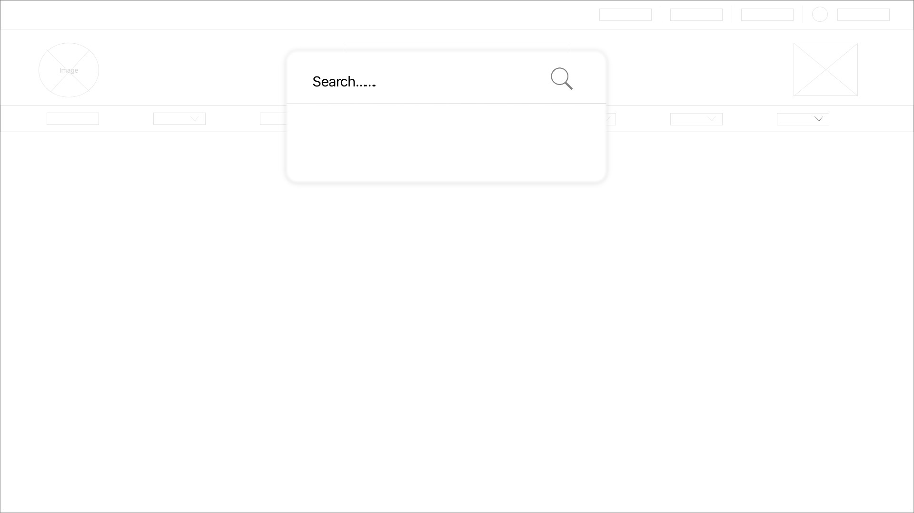

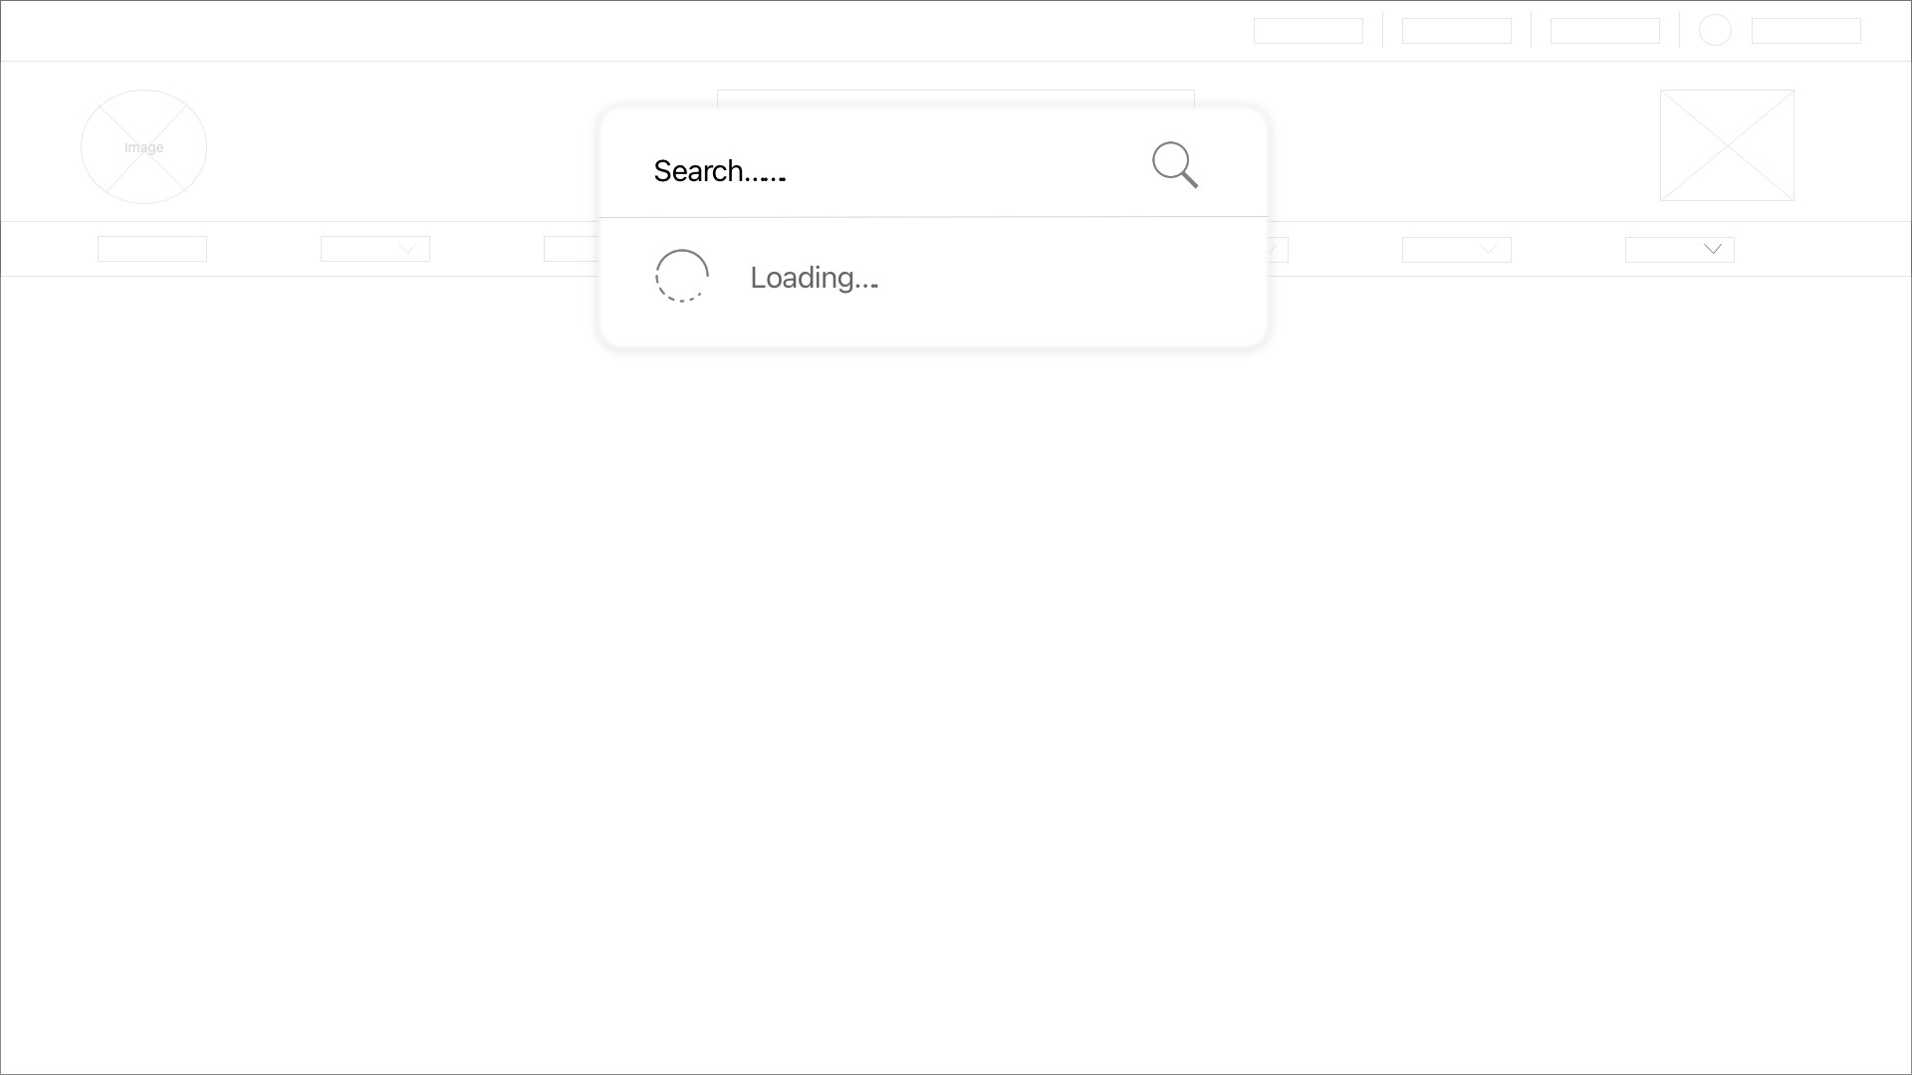

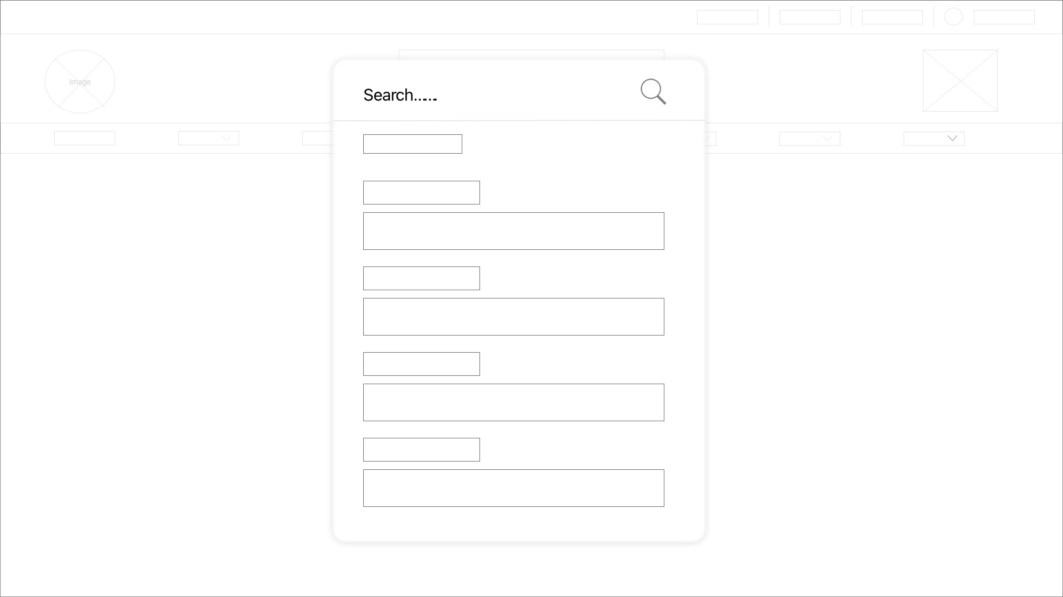

1. Voter roll page

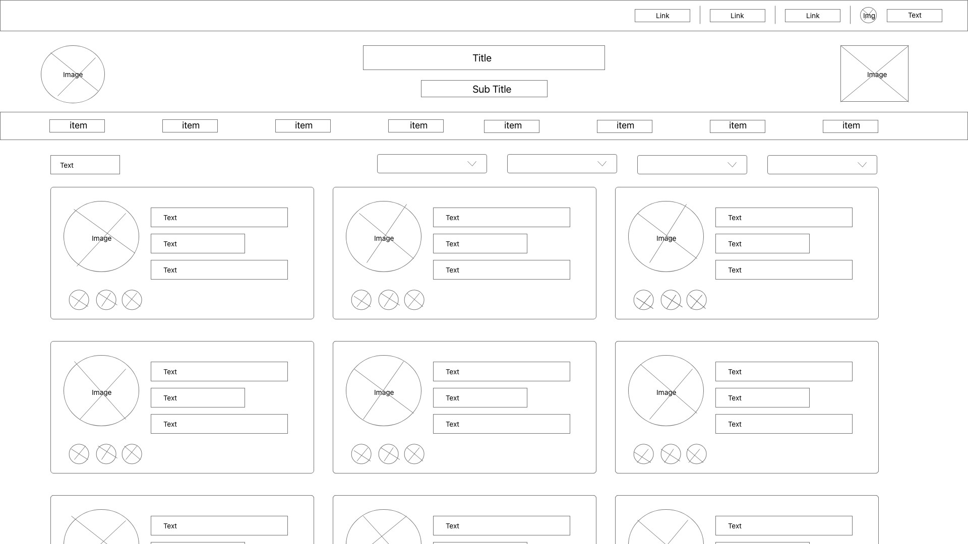

1. Voter details page

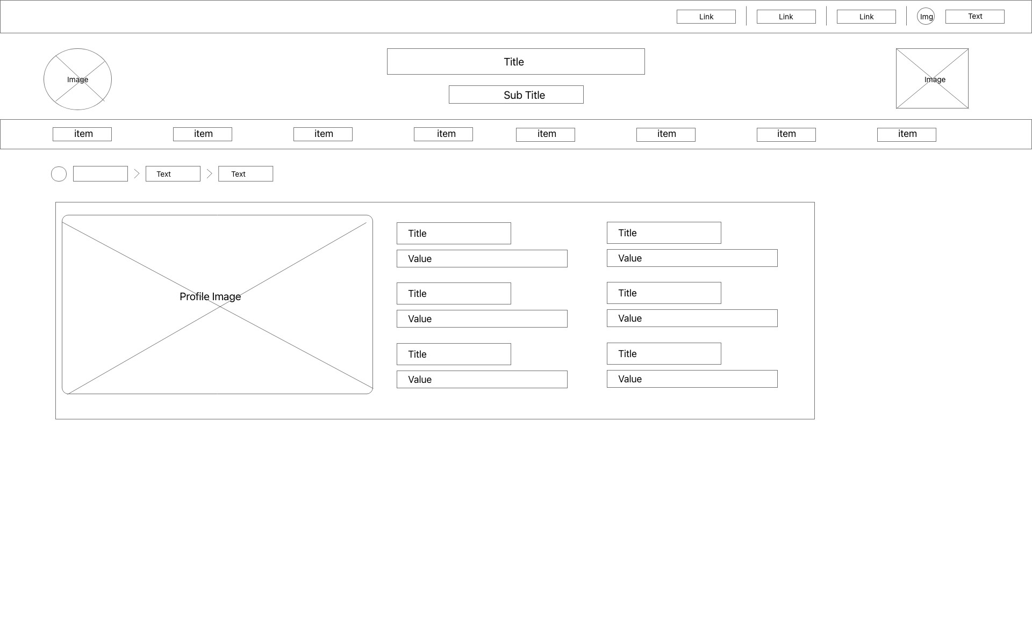

1. Voter eligibility page



1. Voter FAQ page

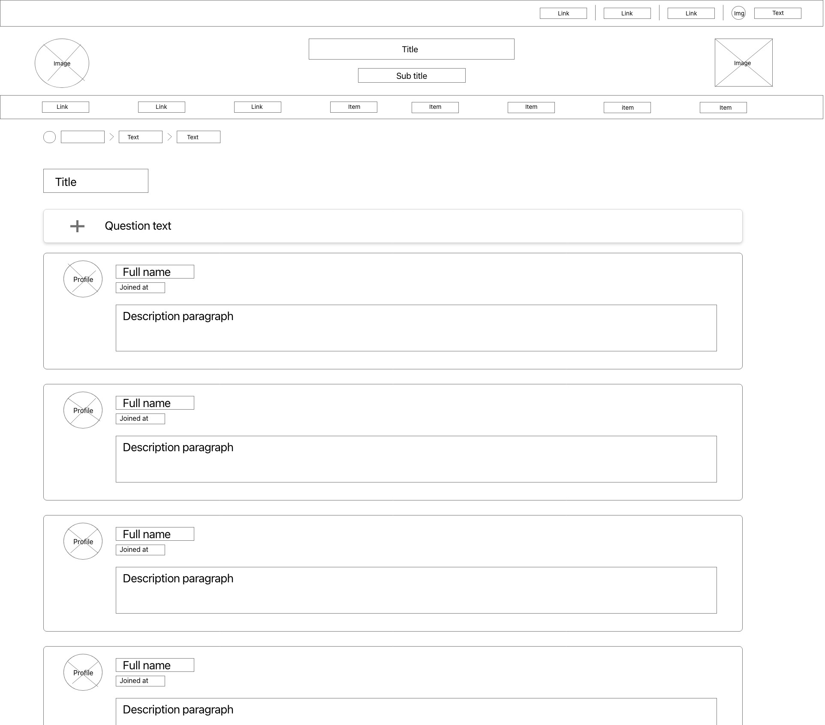

# CLASS DIAGRAM

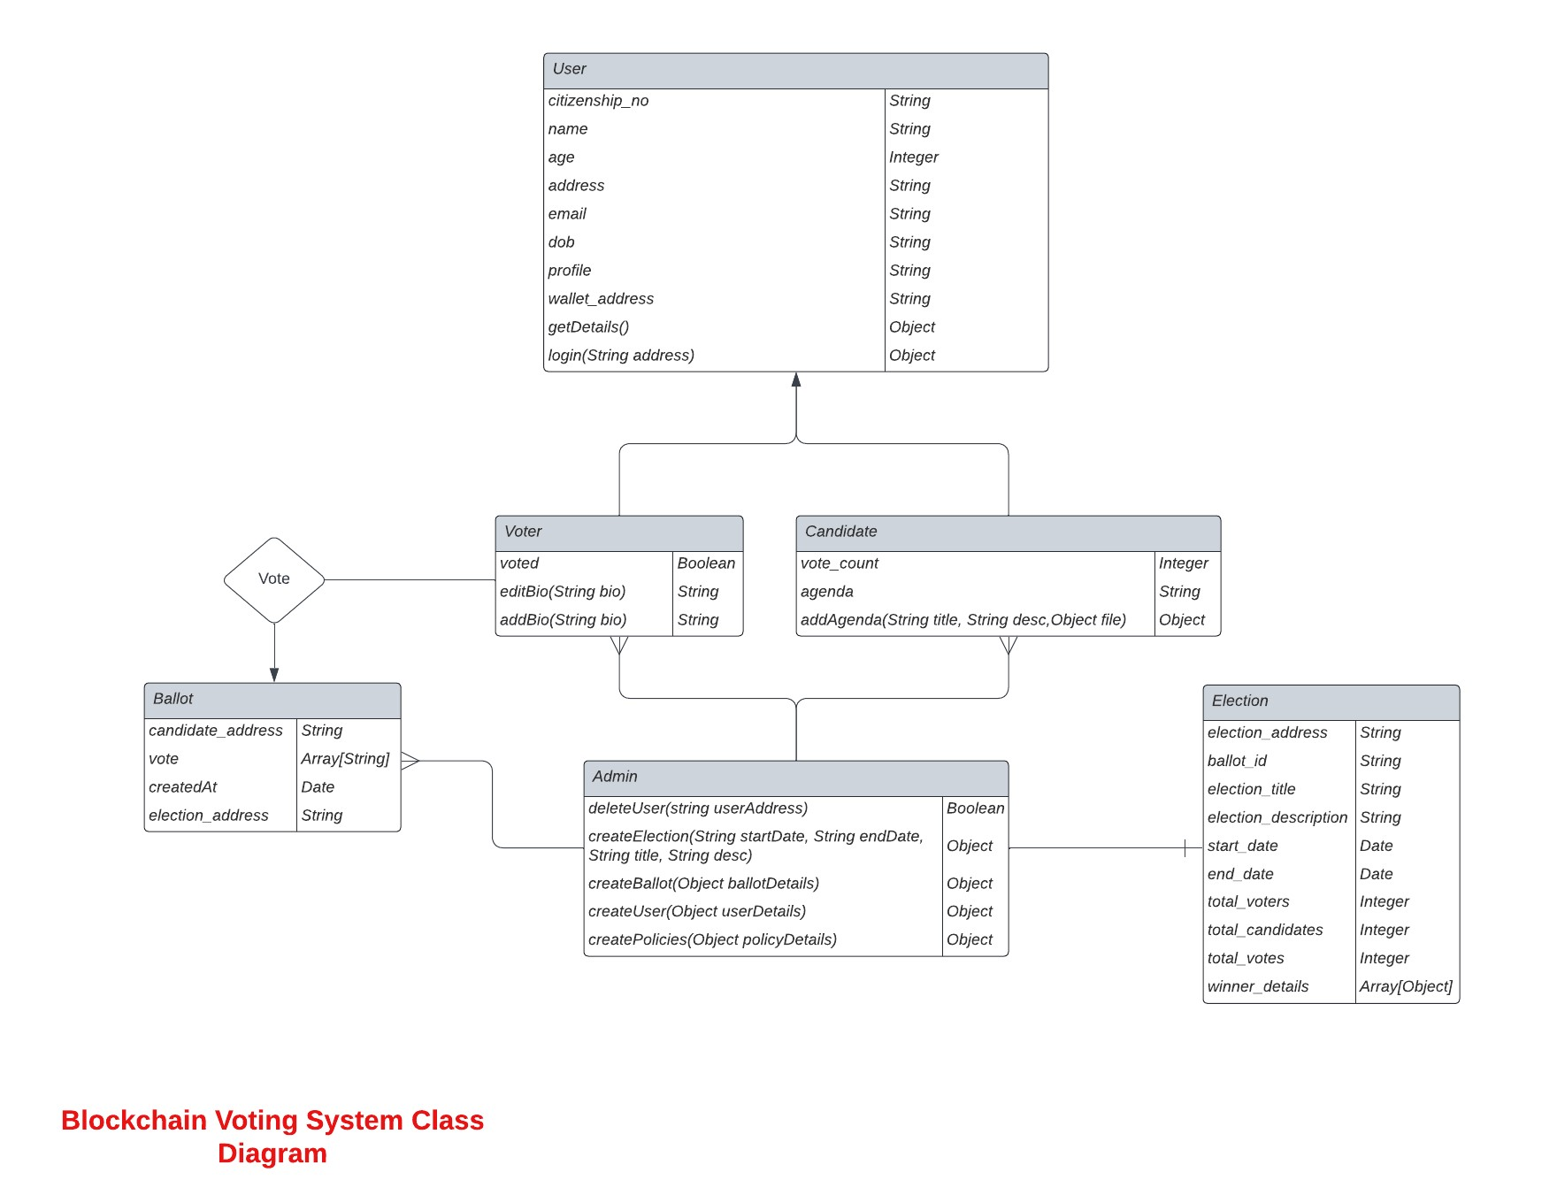

# ERD Diagram

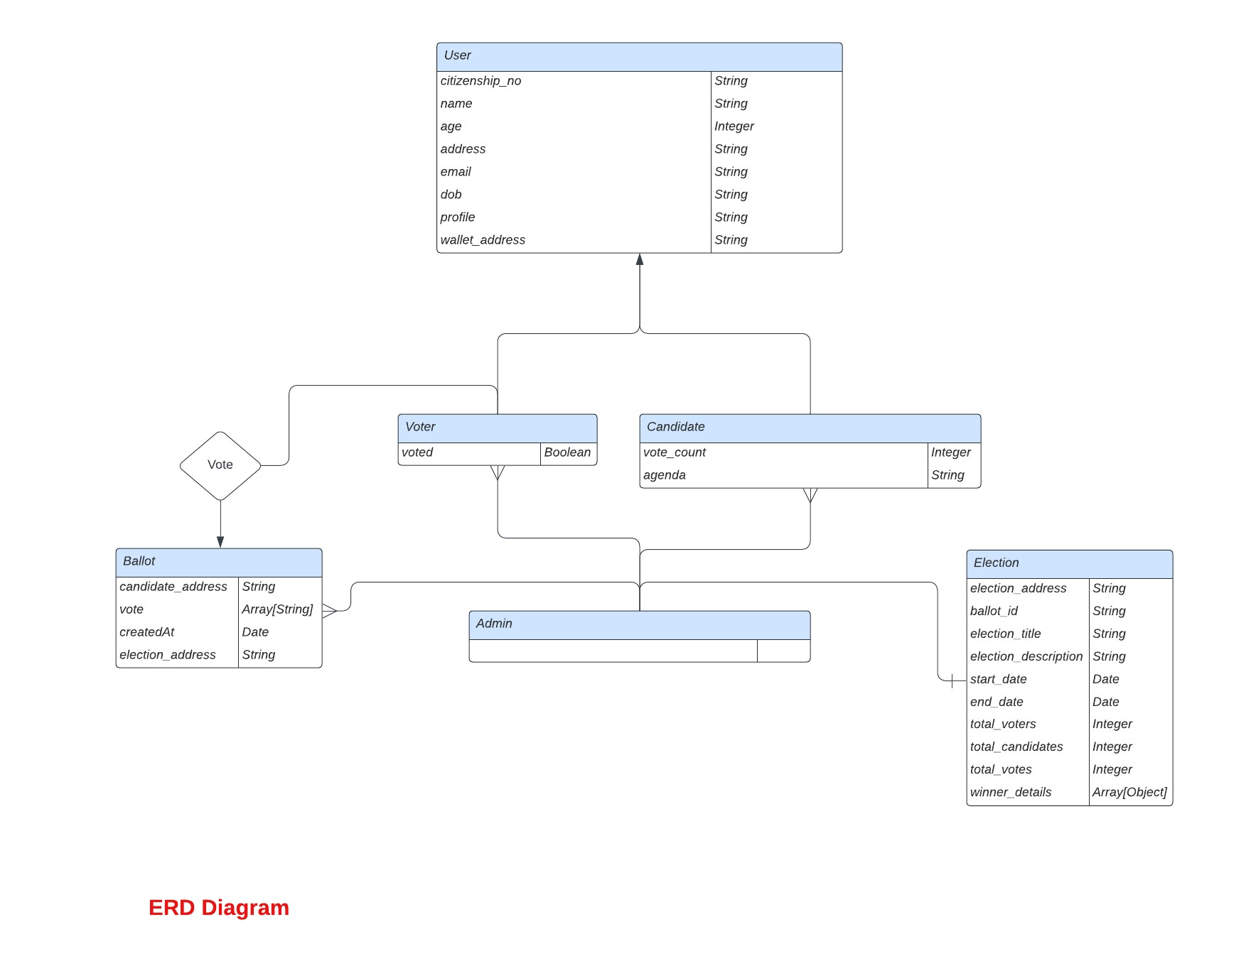

# Data Dictionary

1. Candidate

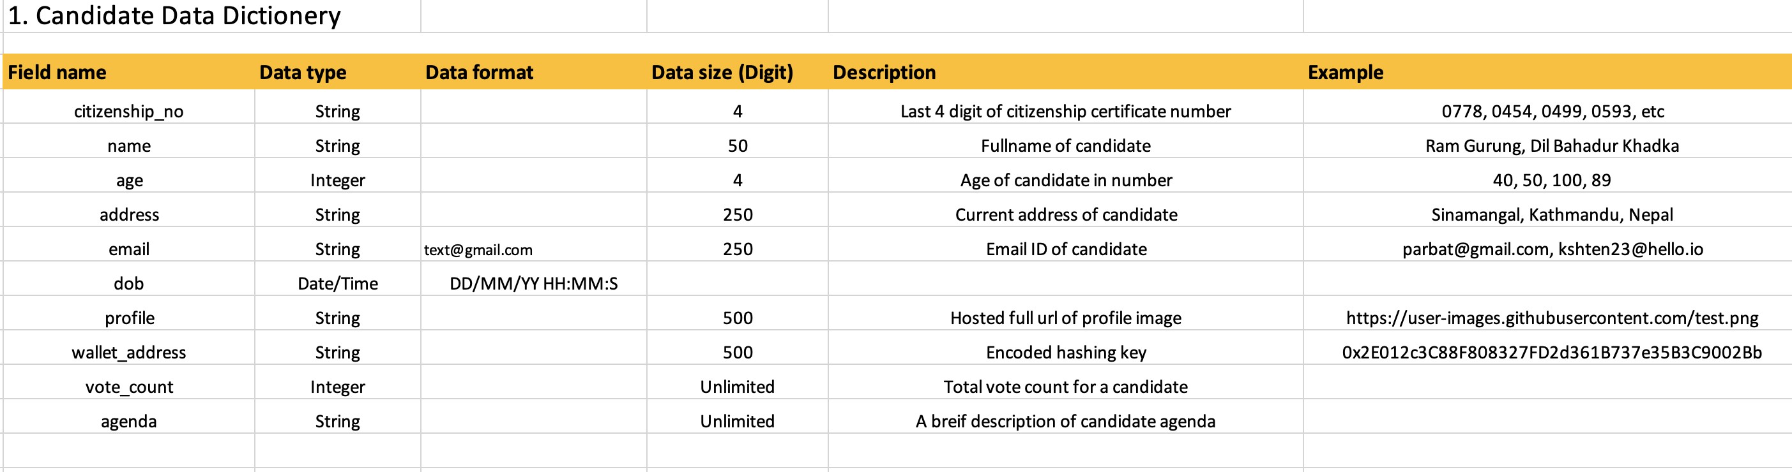

1. Voter

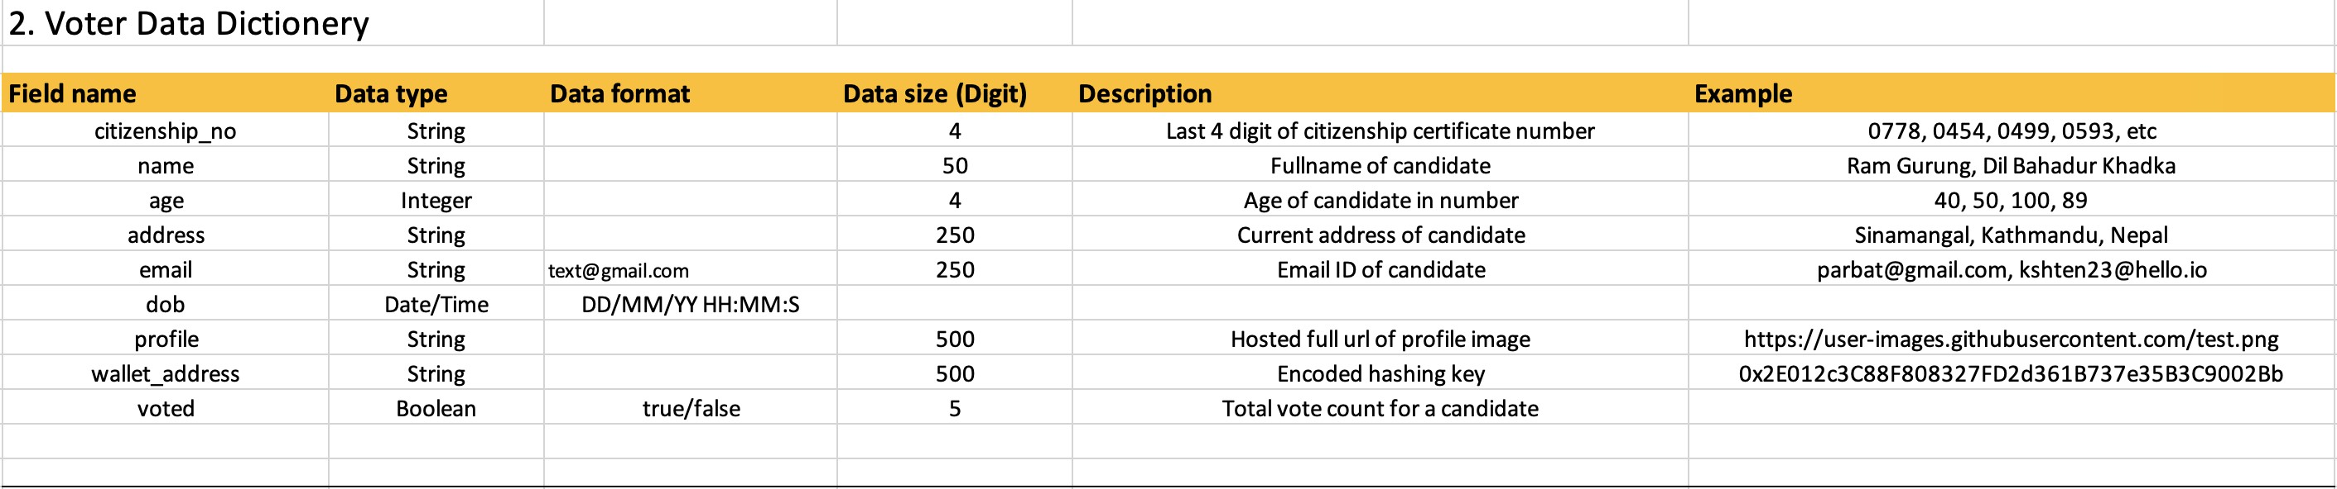

1. Admin

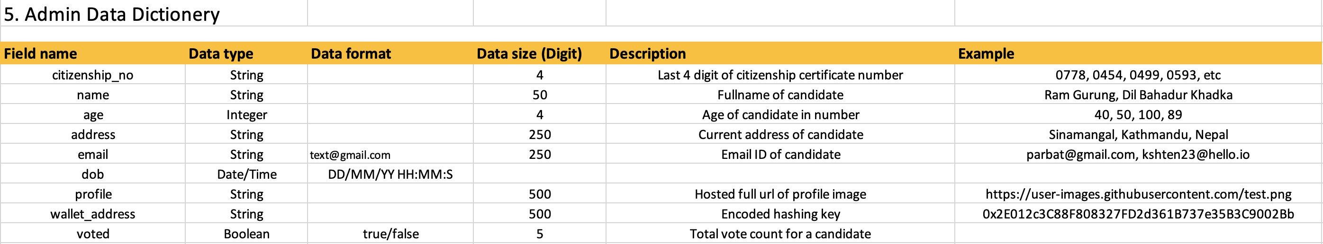

1. Election

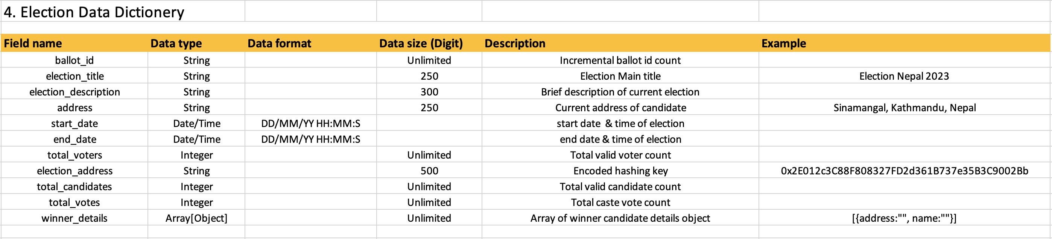

1. Ballot

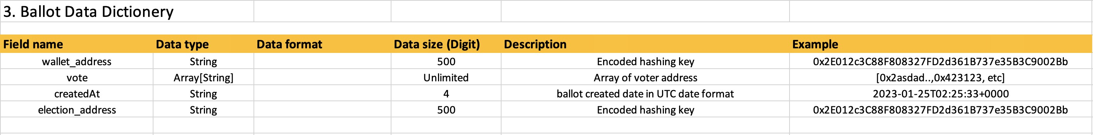

# Sequence Diagram

